**Unit 7: Testing and Ethics in Cloud-Based Development**

Building on the foundation established in Unit 6, this unit focuses on extending and integrating a relational database consistent with the previously created Entity Relationship Model (ERM). It emphasizes enhanced security, ethical considerations, and operational scalability to deliver a fully functional inventory management system for GotNoChill. The project incorporates comprehensive testing at all levels to ensure the system is ready for a pilot phase with PrimePath Provisioning, an e-commerce client.

**Objectives of Unit 7**

* Build and test the relational database schema locally using PostgreSQL.
* Deploy the database to Azure SQL Database for cloud scalability.
* Conduct multi-level testing (unit, end-to-end, and business acceptance testing).
* Ensure secure access through Role-Based Access Control (RBAC) policies.
* Integrate Azure Sentinel for advanced monitoring and threat detection.
* Implement principles from the 12-Factor App methodology to improve scalability and maintainability.
* Provide comprehensive documentation with screenshots for clarity and reproducibility.
* Address ethical considerations in database and AI usage.

**Multi-Level Testing Framework**

**1. Unit Testing (Local Testing)**

* **Overview:** Focuses on verifying the functionality of individual components in isolation.
* **Example:** Testing the getGroceries() service locally within pgAdmin to ensure accurate results.
* **Tools Used:** Pytest for Python-based testing, SQL query validation within pgAdmin.
* **Progress:**
  + Core functions and relationships validated.
  + Foundational stability ensured through isolation testing.

**2. End-to-End Functional Testing**

* **Overview:** Verifies the seamless integration of components across the system to simulate real-world scenarios.
* **Example:** Testing the workflow of the ordering page, including capturing payment data, submitting JSON to an Azure storage account, and ensuring data flows to the inventory system.
* **Key Benefits:** Uncovers issues in the full system workflow.
* **Progress:**
  + Testing confirmed that API endpoints (Flask integration) retrieve posts, add new posts, and track interactions.
  + Data consistency ensured between local PostgreSQL and Azure SQL Database.

**3. Final Business Acceptance Testing**

* **Overview:** Validates the system’s readiness to meet client requirements and supports a pilot launch.
* **Steps:**
  + Simulated user sessions to assess the customer journey.
  + Real-world testing of security and scalability configurations in Azure.
* **Progress:**
  + Client approval received for testing scenarios.
  + PrimePath Provisioning is ready for a pilot phase.

**Database Development and Deployment**

**PostgreSQL Implementation (Local Development)**

1. **Database Setup:** Created a new database (gotnochill) in pgAdmin for local development.
2. **Schema Design:** Tables defined for users, posts, and analytics, with relationships and constraints validated using SQL queries.
3. **Query Testing:** Verified data integrity and performance using realistic sample data.

**Azure SQL Database Implementation**

1. **Database Deployment:** Configured a new Azure SQL Database (gotnochill) with scalability and security options.
2. **Schema Migration:** Successfully migrated schema from PostgreSQL to Azure SQL.
3. **Security Configuration:** Applied RBAC policies to restrict access and ensure data privacy.
4. **Query Validation:** Repeated local testing in the cloud environment to confirm consistent results.

**Integration of Azure Sentinel for Monitoring and Threat Detection**

Azure Sentinel was implemented to enhance the system’s resilience by providing real-time monitoring, threat detection, and automated incident response. Key steps include:

1. **Log Analytics Workspace Setup**
   * Created a workspace named loggotnochill in the East US region for data collection and analysis.
2. **Adding Azure Sentinel**
   * Enabled Azure Sentinel for the workspace to configure security monitoring capabilities.
3. **Analytics Rule Creation**
   * **Suspicious Sign-Ins Rule:** Detects more than five failed sign-in attempts within a 10-minute window to identify potential brute force attacks.
   * **Multistage Attack Detection:** Leverages built-in detection logic to identify and respond to complex attack patterns.
4. **Automation Rules**
   * Triggers incidents to notify the security team and prioritize critical alerts.
5. **Monitoring Results**
   * Active rules reduce noise by grouping related alerts into incidents, streamlining investigations.

**Implementation of 12-Factor App Principles**

To ensure scalability, maintainability, and seamless deployment, the project adheres to the 12-Factor App methodology. The key principles implemented include:

1. **Codebase**
   * A single codebase is maintained and version-controlled using GitHub, ensuring consistency across environments.
2. **Dependencies**
   * Dependencies are explicitly declared and managed using NuGet and inversion of control frameworks in Azure.
3. **Config Stores**
   * Configuration variables are stored securely using Azure Secret Manager to separate code from configurations.
4. **Backing Services**
   * Azure functions and attached services, such as the Azure SQL Database and Blob Storage, are treated as external resources, enabling easy scaling and replacement.
5. **Build, Release, Run**
   * These states are separated to streamline the CI/CD pipeline. Unit tests are run locally, followed by deployment to a lower environment for integration testing.
6. **Processes**
   * Stateless processes are used for handling requests, ensuring scalability and avoiding session dependency.
7. **Port Binding**
   * The portal app runs on port 5000 for containers, with routing set up for alternative sites (e.g., an experimental Spanish-English version on port 8081).
8. **Concurrency**
   * Applications scale horizontally by running on containers managed by Docker.
9. **Disposability**
   * The containerized app starts quickly and can be stopped without affecting other components.
10. **Dev/Prod Parity**
    * Development, staging, and production environments are kept as similar as possible to avoid unexpected behavior during deployment.
11. **Logs**
    * Logs are treated as event streams, with JSON formatting for consistency. Logs are sent to Azure Monitor for real-time insights.
12. **Admin Processes**
    * Administrative tasks, such as database migrations, are managed through automated GitHub workflows and Azure elastic scaling services.

**Ethical Considerations in Cloud-Based Development**

**Data Privacy and Security**

* Protecting sensitive user data using RBAC and encryption (in transit and at rest).
* Aligning with GDPR compliance to build user trust and ensure accountability.

**Transparency in Data Usage**

* Explicit disclosure of data collection and usage policies.
* Anonymization of serviceability test data to prevent unauthorized exposure of personally identifiable information.

**Bias Mitigation**

* Regular audits of AI-driven analytics to prevent algorithmic bias.
* Ensuring geographic and demographic neutrality in serviceability results.

**Accessibility and Sustainability**

* Implementing web accessibility standards for inclusivity.
* Leveraging Azure’s carbon-neutral hosting to minimize environmental impact.so make

**Part 2: Team Contribution – Screenshots**

**Unit 4: Screenshot Table of Contents**

**QuickLink**

1. Azure Function: (Figures 1-3)
2. Azure Function Test Results: (Figures 4-11)
3. Azure Storage Account:
4. Frontend/Backend on Glitch PaaS: (Figures 12-13)
5. Entity Relationship Model (ERM): (Figure 14)

**Unit 5: Screenshot Table of Contents**

**Quicklink**

1. Azure Monitor Setup : (Figures 15-18)
2. Azure Container App Deployment: (Figures 19-20)
3. Ping Test Results: (Figures 21-26)
4. Performance Analysis: (Figures 27-30)
5. Frontend and Backend API Integration: (Figure 31)
6. Layer 2: Implementation View: (Figure 32)
7. Updated Entity Relationship Model (ERM): (Figure 33)
8. Development Environment Update: (Figures 34-35)

**Unit 6: Screenshot Table of Contents**

**Quick****Link**

1. Azure App Services Deployment: (Figures 36-37)
2. RBAC Configuration in Azure Active Directory: (Figures 38)
3. Azure Monitor Dashboard: (Figures 39)
4. Frontend Live Analytics Dashboard: (Figures 40-41)
5. NSG Rule Updates: (Figure 42)
6. Backup and Recovery Enhancements: (Figures 43-44)

**Unit 7 Screenshot Table of Contents**

**Quicklink**

1. PostgreSQL Implementation (Figures 45-48)
2. Azure SQL Database Implementation: (Figures 49-58)
3. Azure Sentinel Configuration: (Figures 59-71)
4. Testing Framework: (Figure 72-75)
5. 12-Factor App Implementation: (Figure 76-82)
6. AI and Cloud Based Ethical Frameworks & Bias Mitigation: (Figures 83-84)

**Unit 4 Screenshots:**

**Azure Function:**

**(Figure 1-3)**

***Figure 1:***

***Azure Function App Configuration*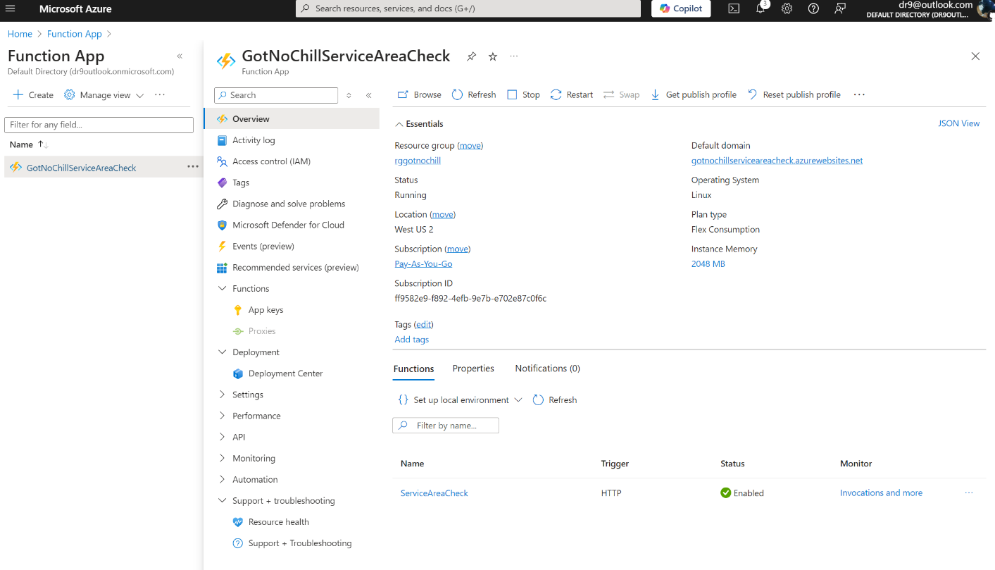**

***Figure 2:***

***Test/Run ServiceAreaCheck with valid ZIPcode = 99362*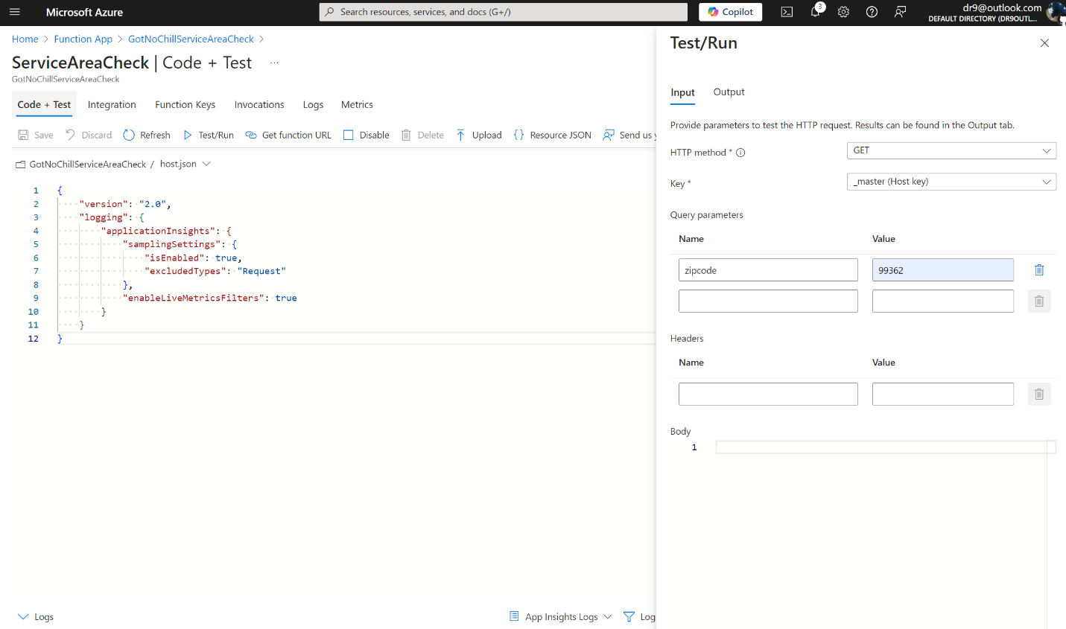**

***Figure 3:***

**Returned Response / 200 OK, and JSON Payload  
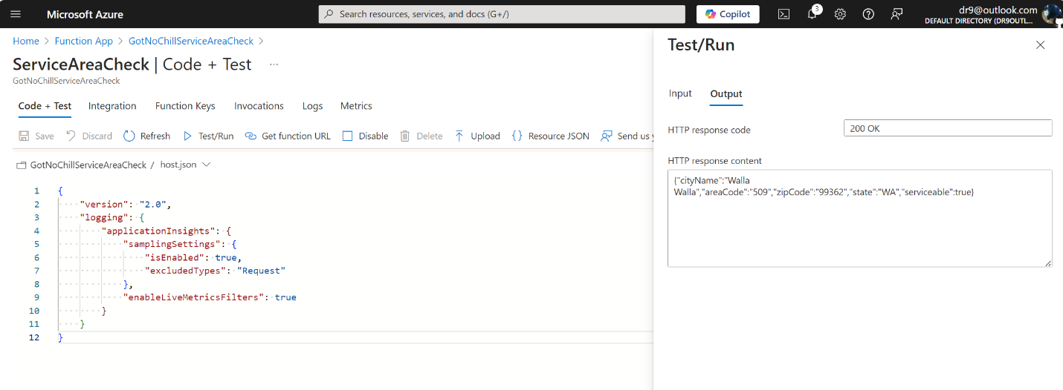**

**Azure Storage:**

**(Fig 4- 11)**

***Figure 4:***

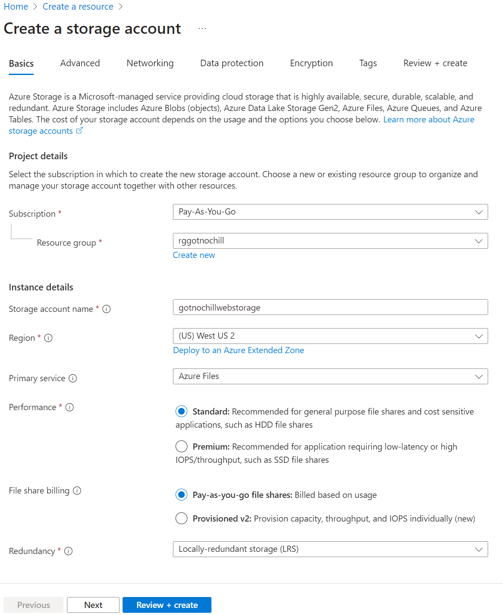

***Figure 5:***

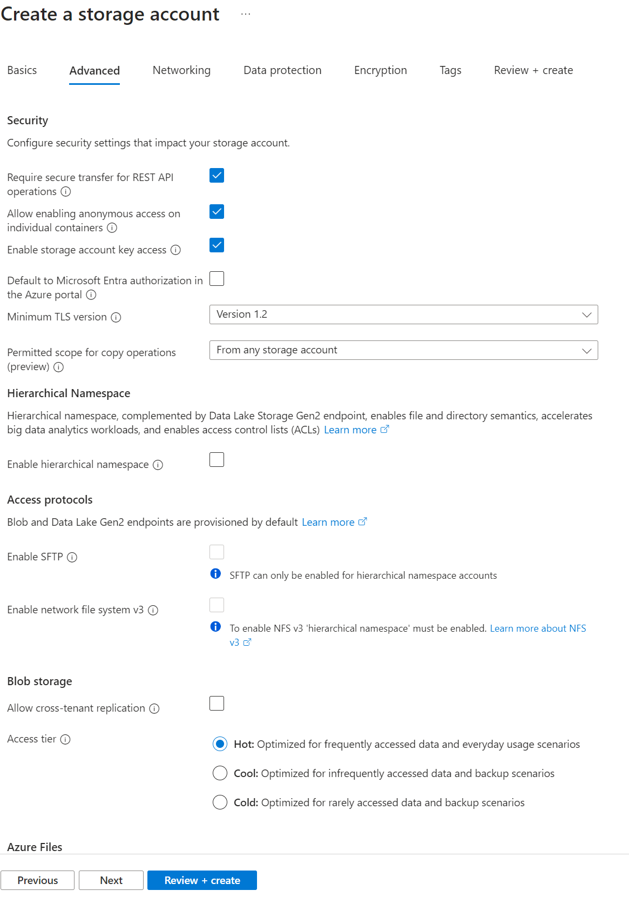

***Figure 6:***

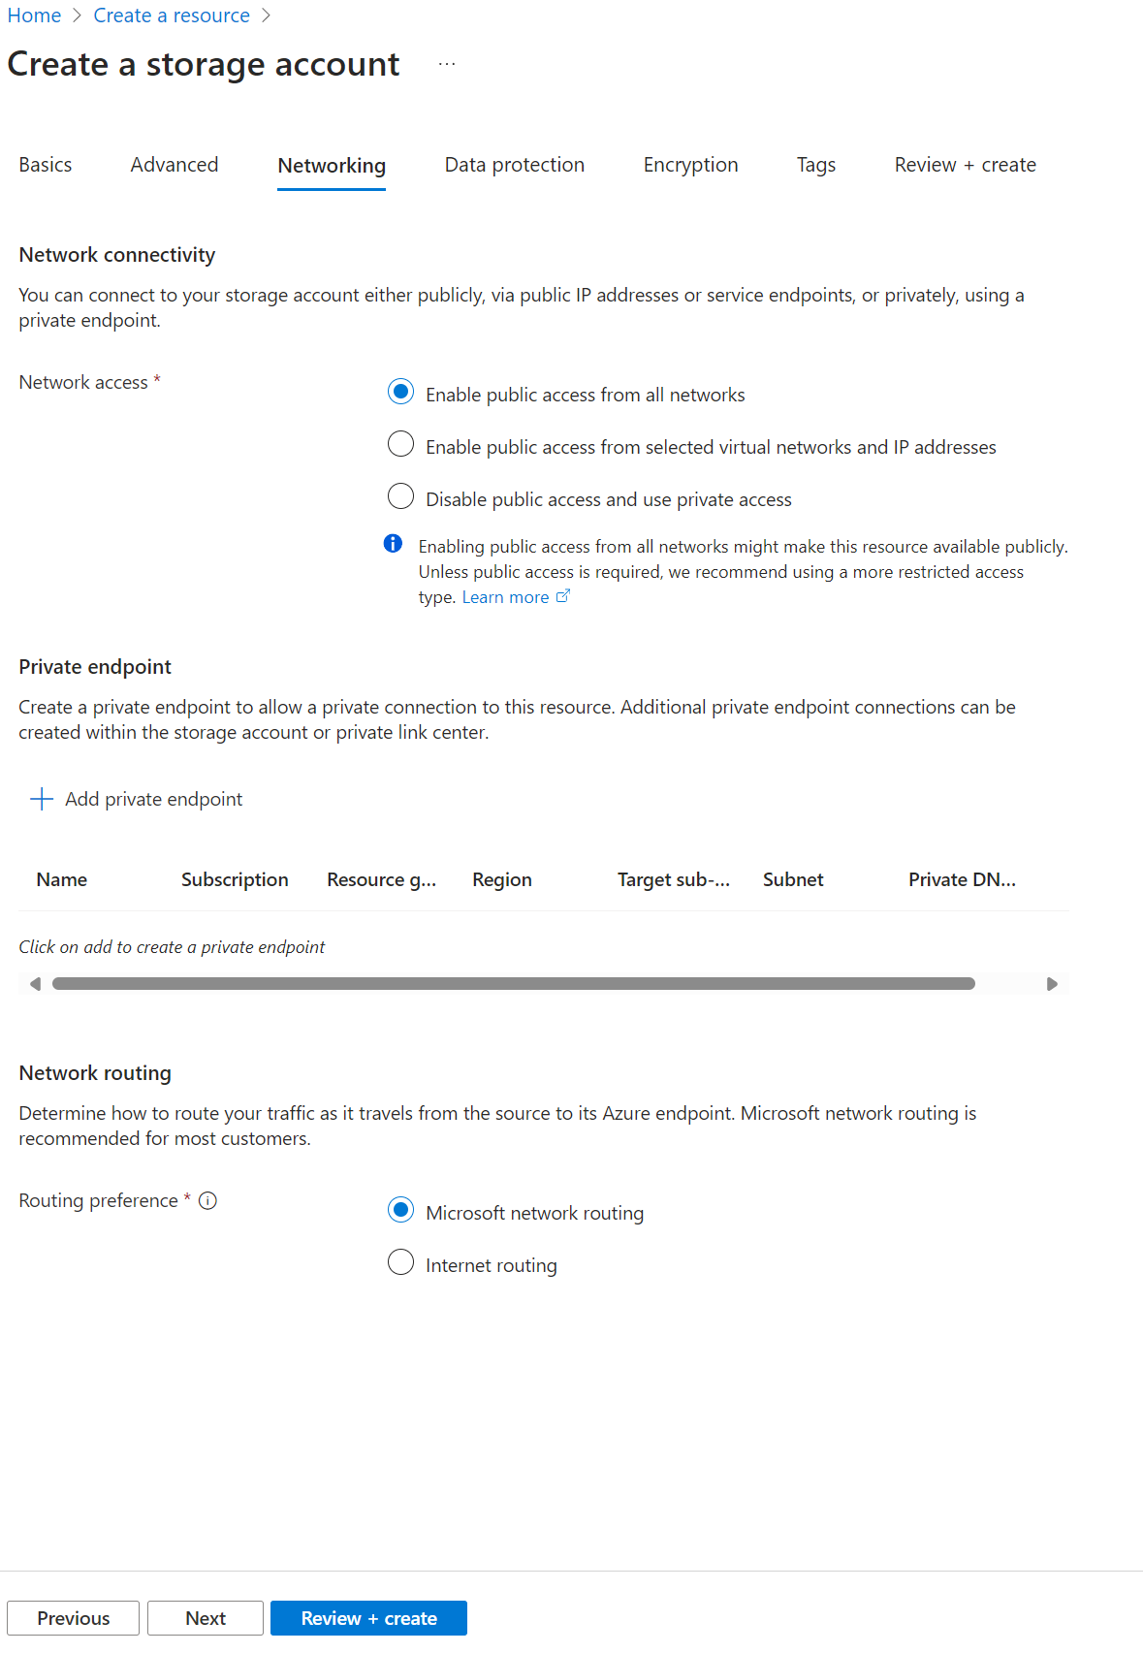

***Figure 7:***

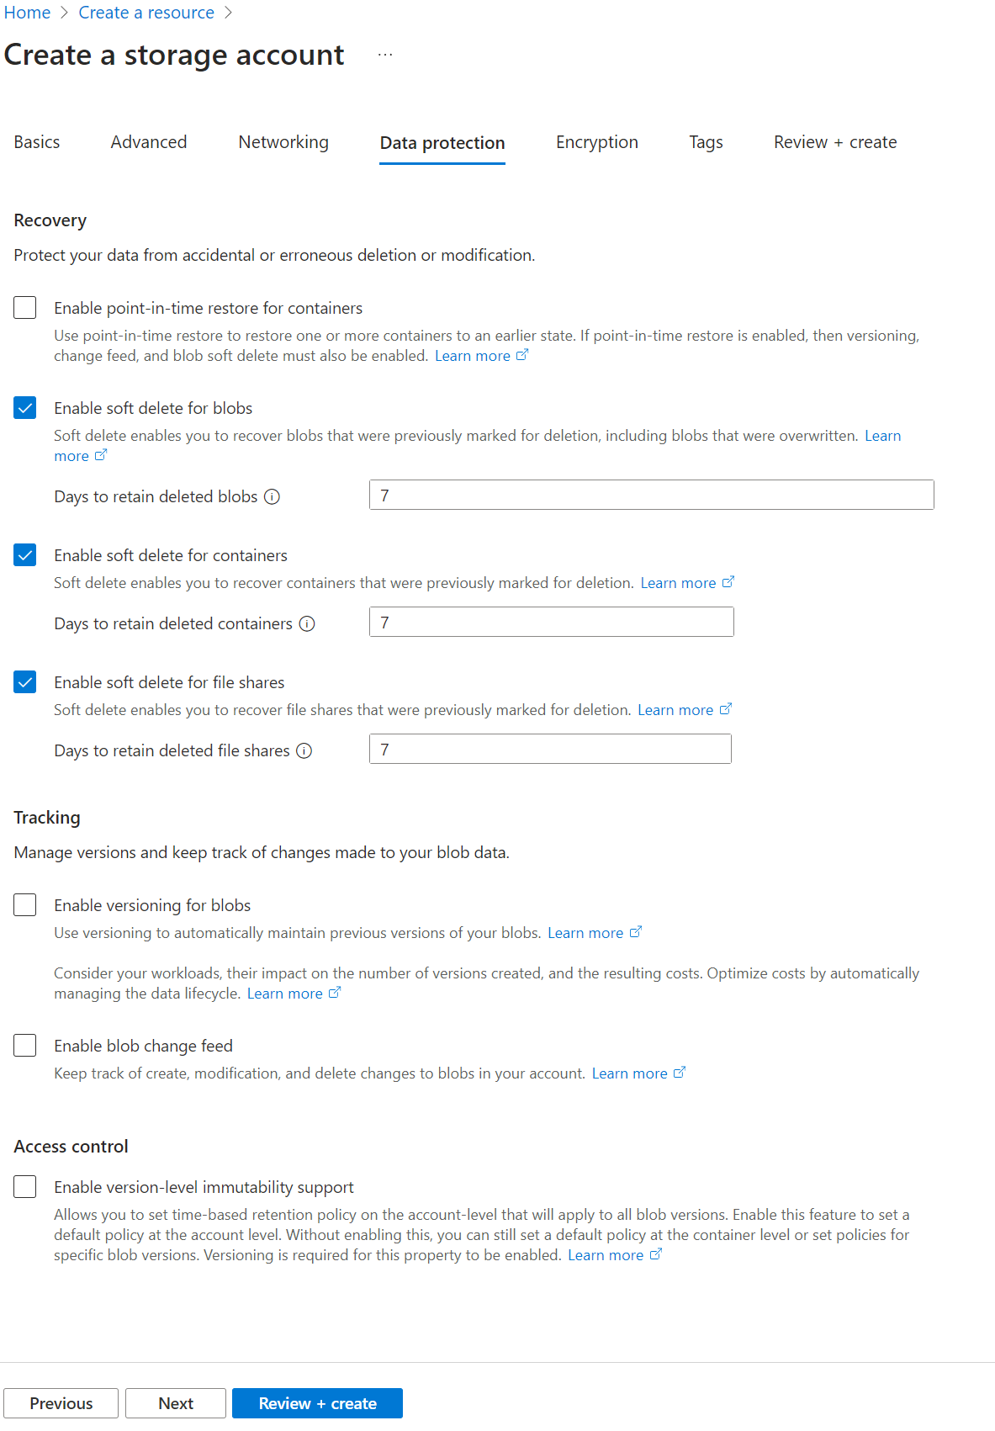

***Figure 8:***

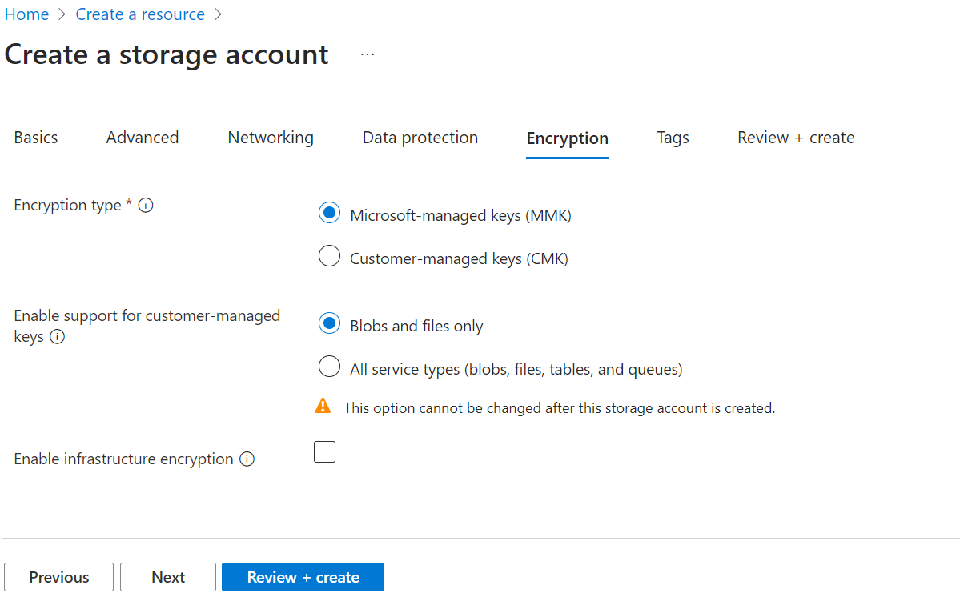

***Figure 9:***

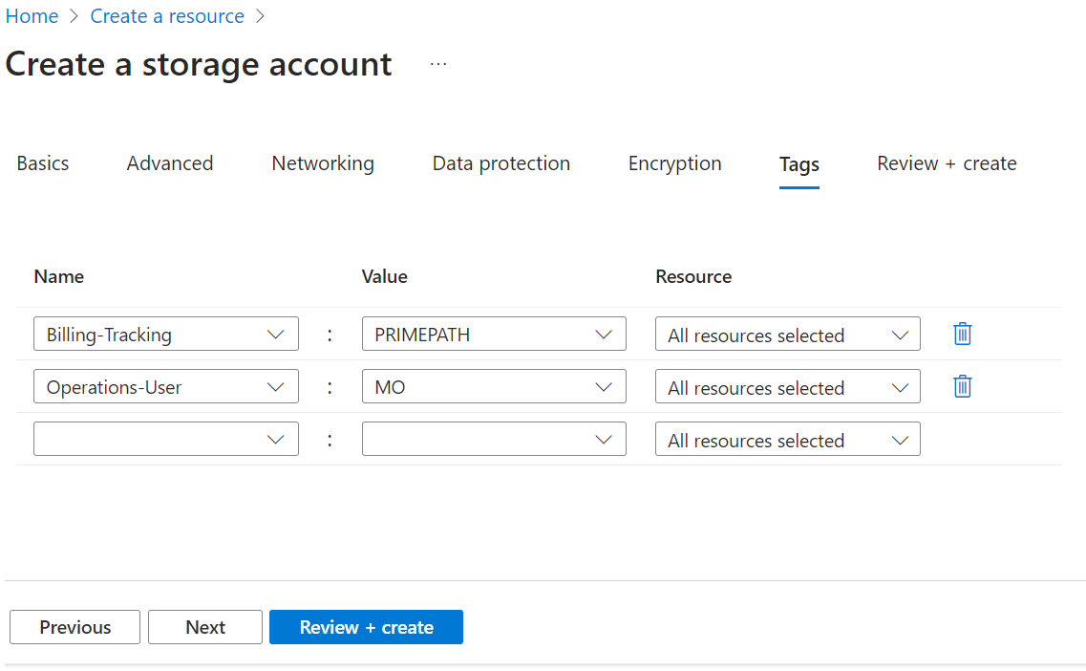

***Figure 10:***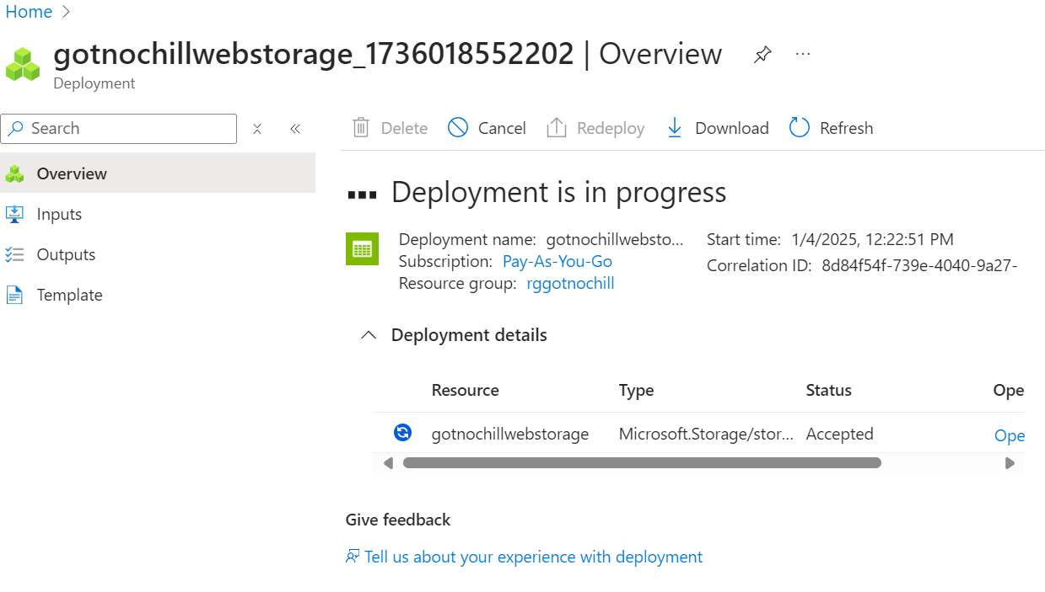

***Figure 11***

**.**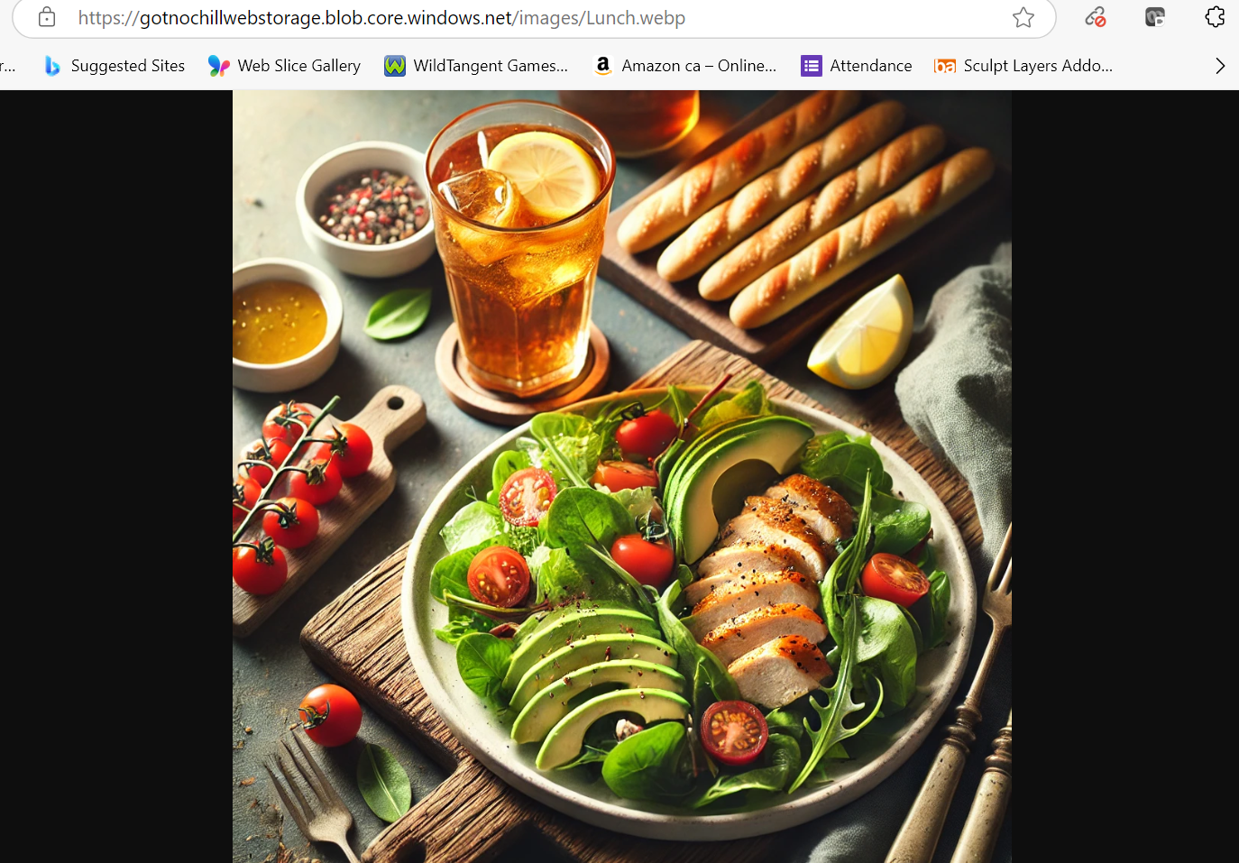

**Front-end Glitch PaaS:**

**(Fig 12-13)**

***Figure 12:***

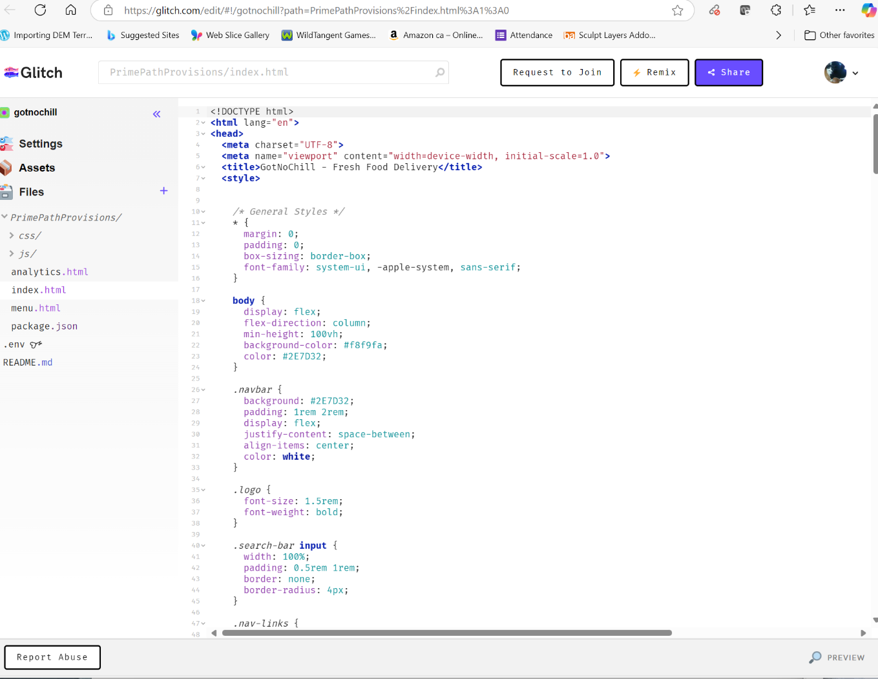

***Figure 13:* 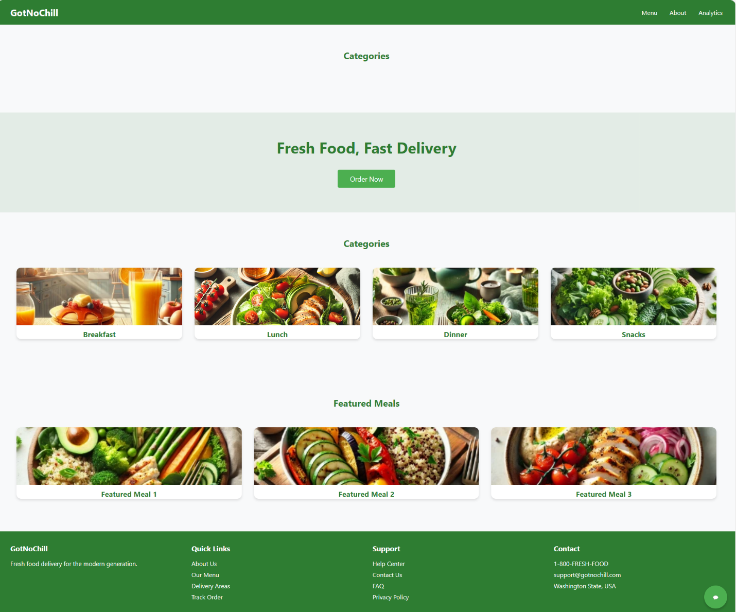**

**Entity Relationship Model (ERM):**

***Figure 14:***

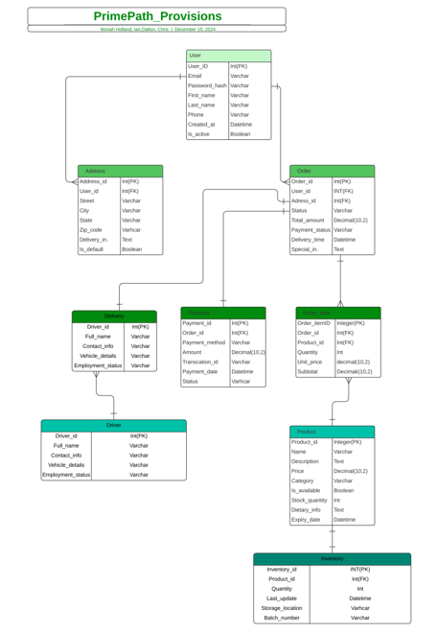

**Unit 5: Screenshots**

**Azure Monitor Dashboard:**

**Figures (15-18)**

***Figure 15:***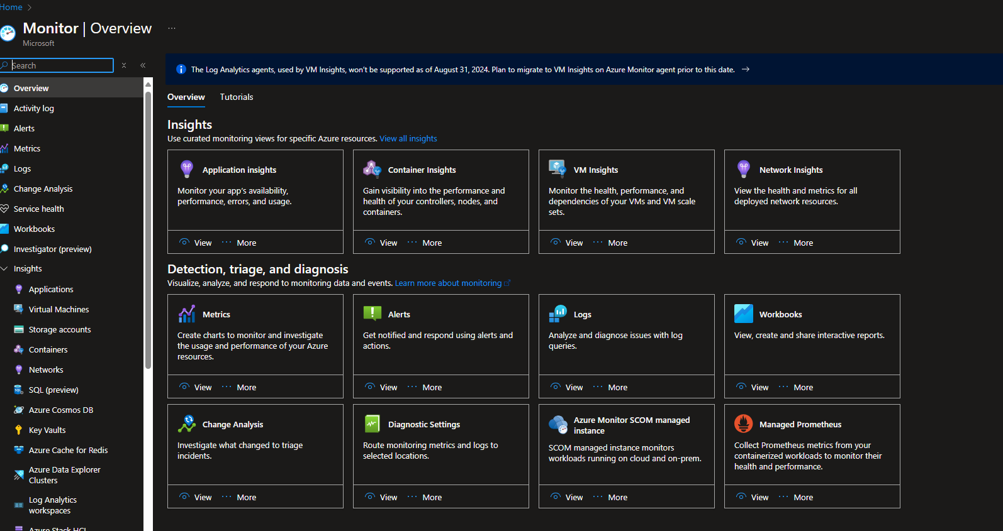

***Figure 16:***

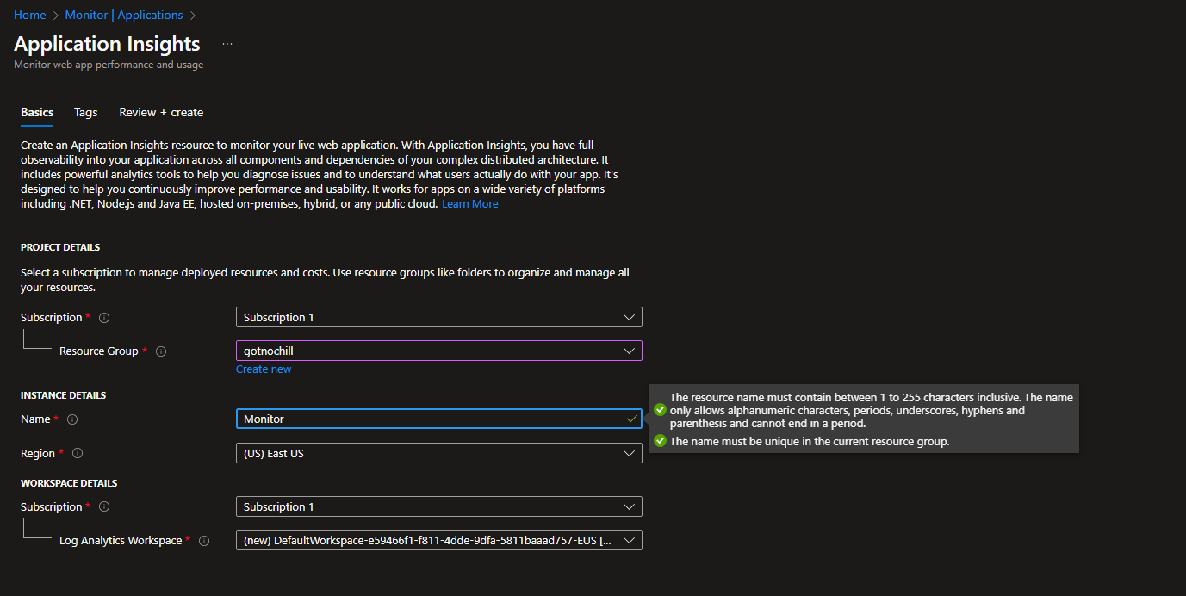

***Figure 17:***

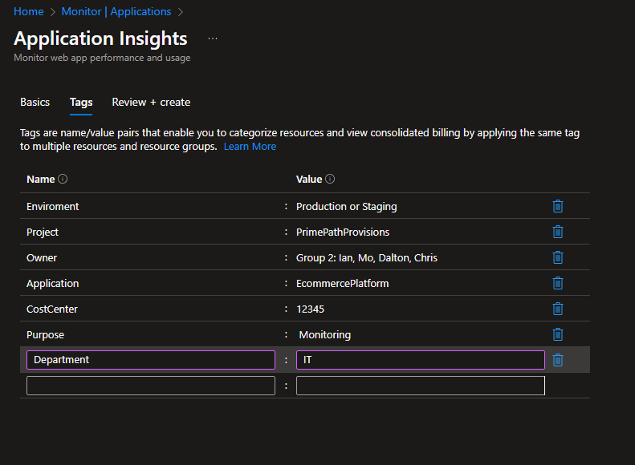

***Figure 18:***

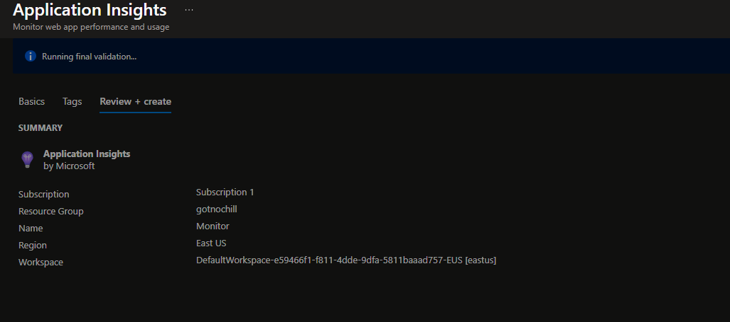

**Azure Container App Deployment:**

**(Figures 19-20)**

***Figure 19:***

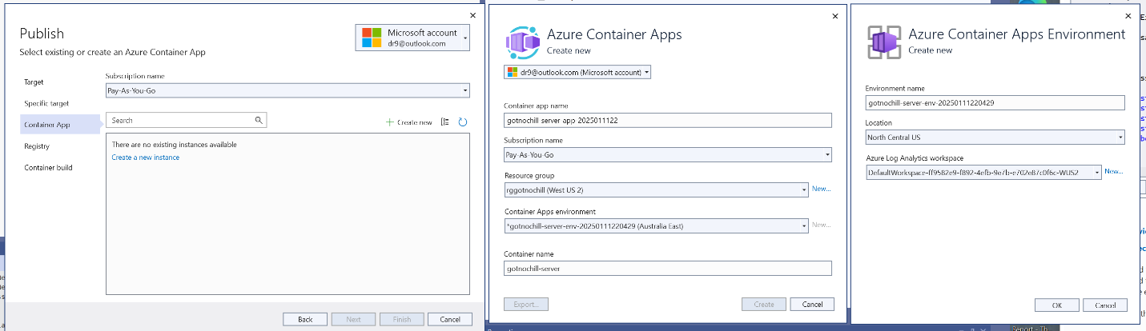

***Figure 20:***

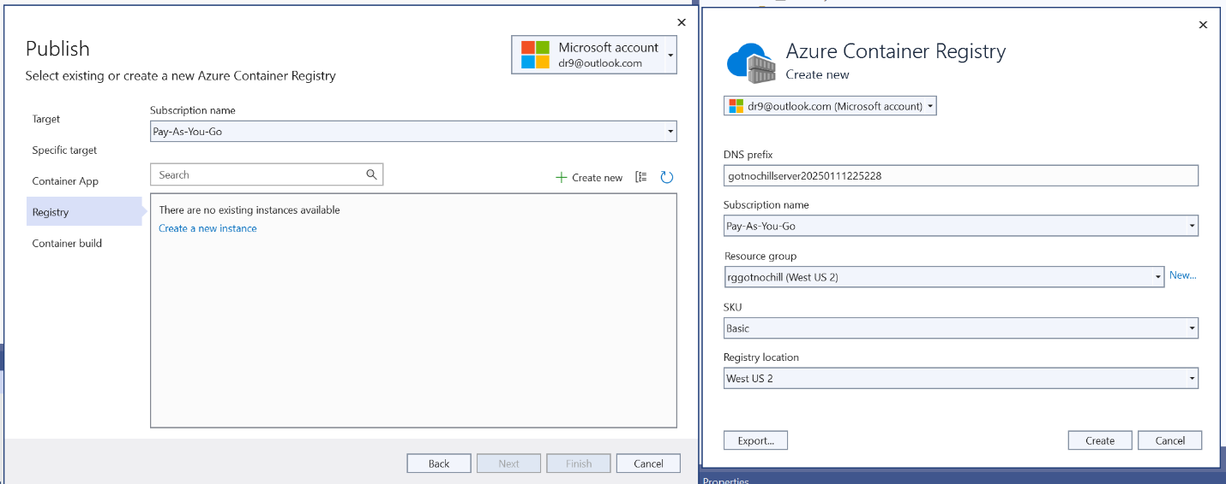

**Ping Testing:**

**(Figures 21-26)**

***Figure 21:***

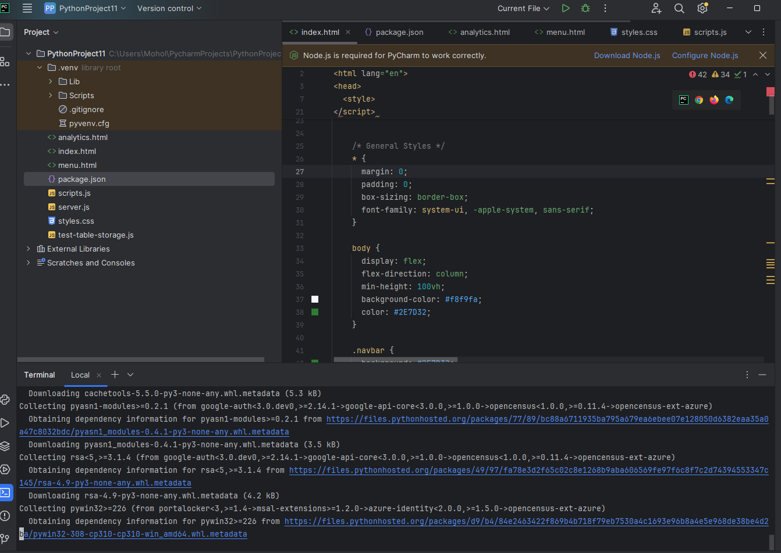

***Figure 22:***

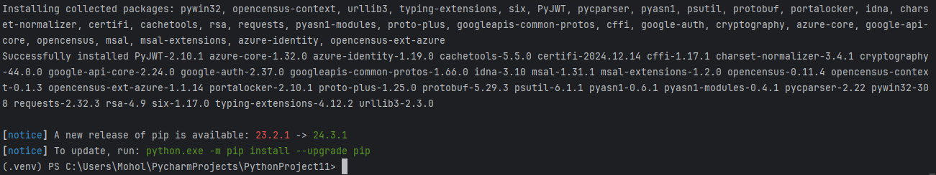

***Figure 23:***

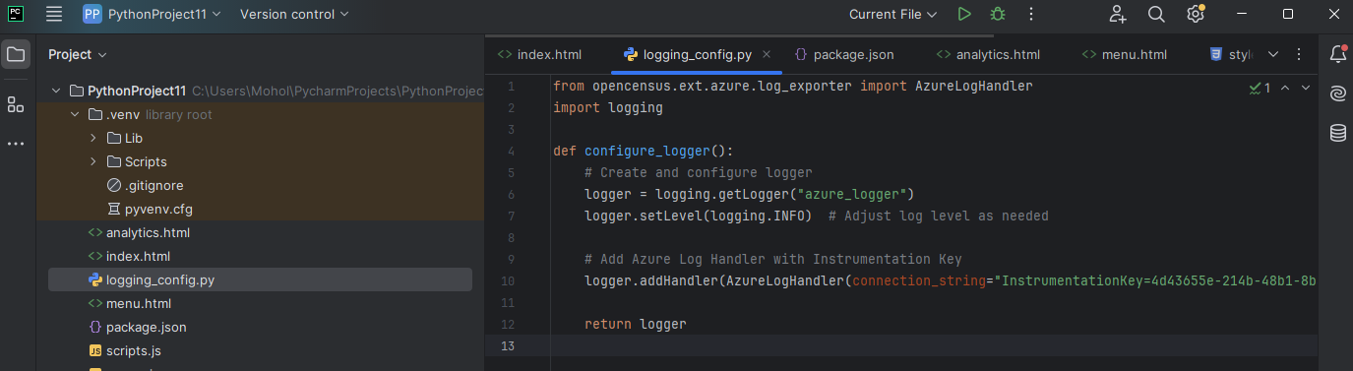

***Figure 24:***

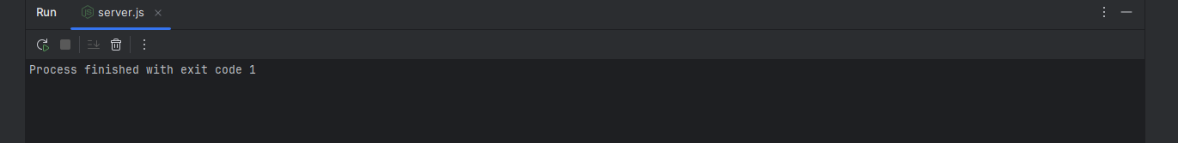

***Figure 25:***

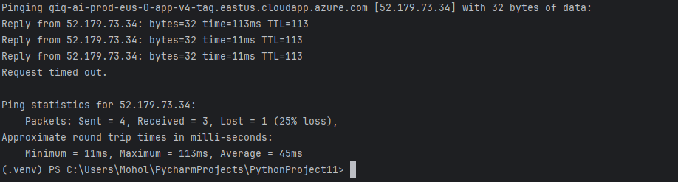

***Figure 26:***

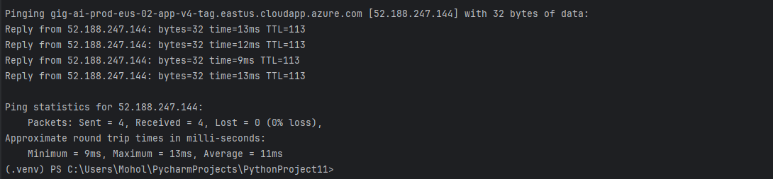

The results of this ping test show that your machine successfully communicated with the Azure ingestion endpoint (eastus.cloudapp.azure.com) without any packet loss, which indicates a stable and reliable network connection to Azure.

All four packets were sent and received successfully (0% packet loss), which confirms that your machine can communicate with the Azure endpoint.

**Performance Analysis :**

**(Figures 27-30)**

***Figure 27:***

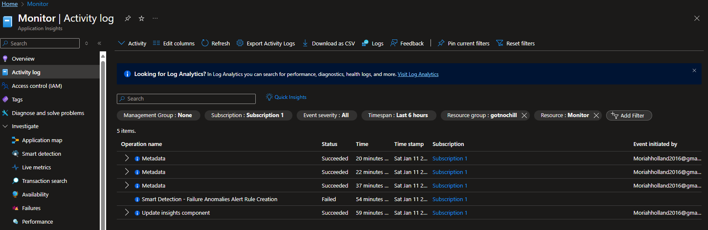

***Figure 28:***

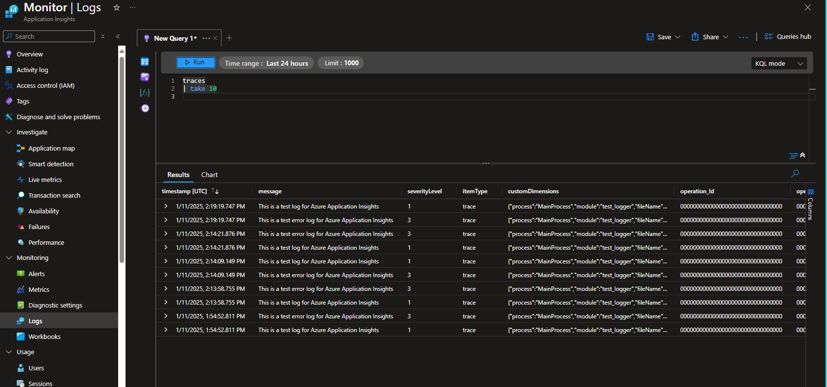

***Figure 29:***

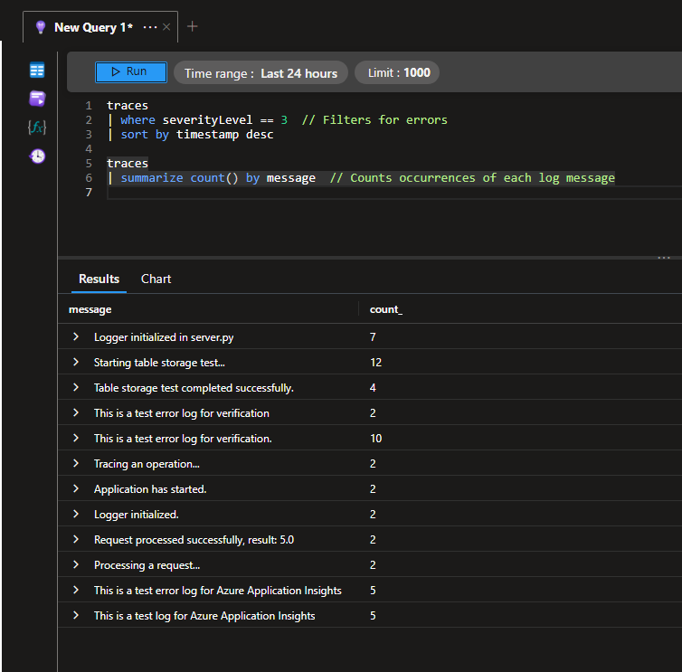

***Figure 30:***

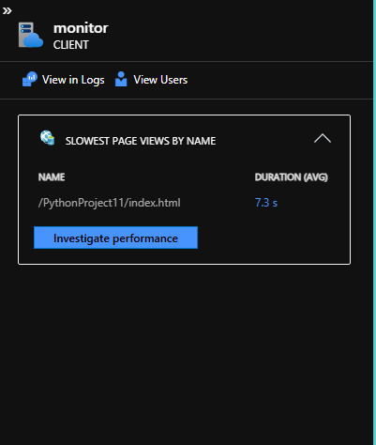

**Frontend and Backend Integration:**

***Figure 31:***

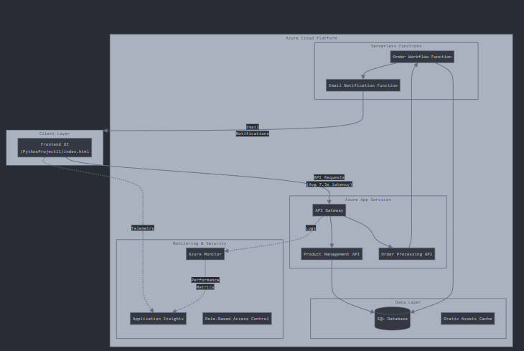

**Layer 2: Implementation View**

***Figure 32:***

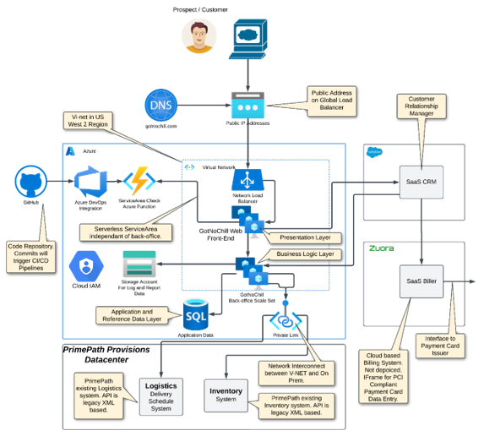

**Updated Entity Relationship Model (ERM):**

***Figure 33:***

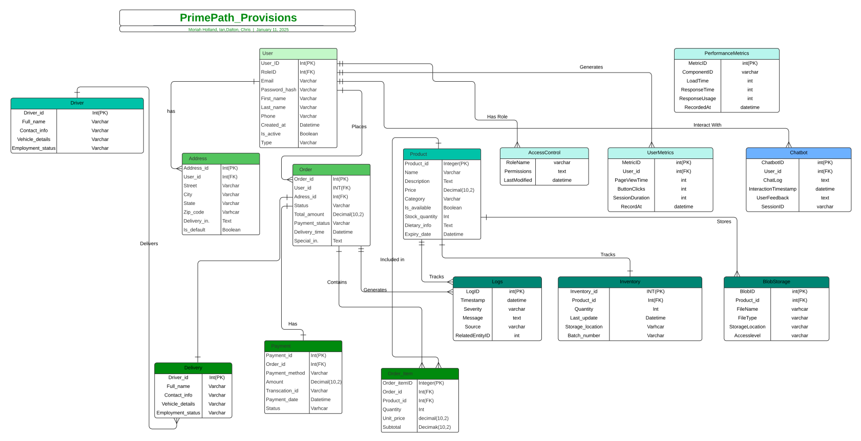

**Live Link:** [**LucidChart Live**](https://lucid.app/lucidchart/ecf392a6-b974-4bc6-ad98-ff86655d7c34/edit?viewport_loc=-563%2C-61%2C4020%2C1981%2C0_0&invitationId=inv_ed5f135d-4276-4354-b597-7ac2f15f7984)

**Development Environment Update:**

**Figures (34-35)**

***Figure 34:***

**Glitch**

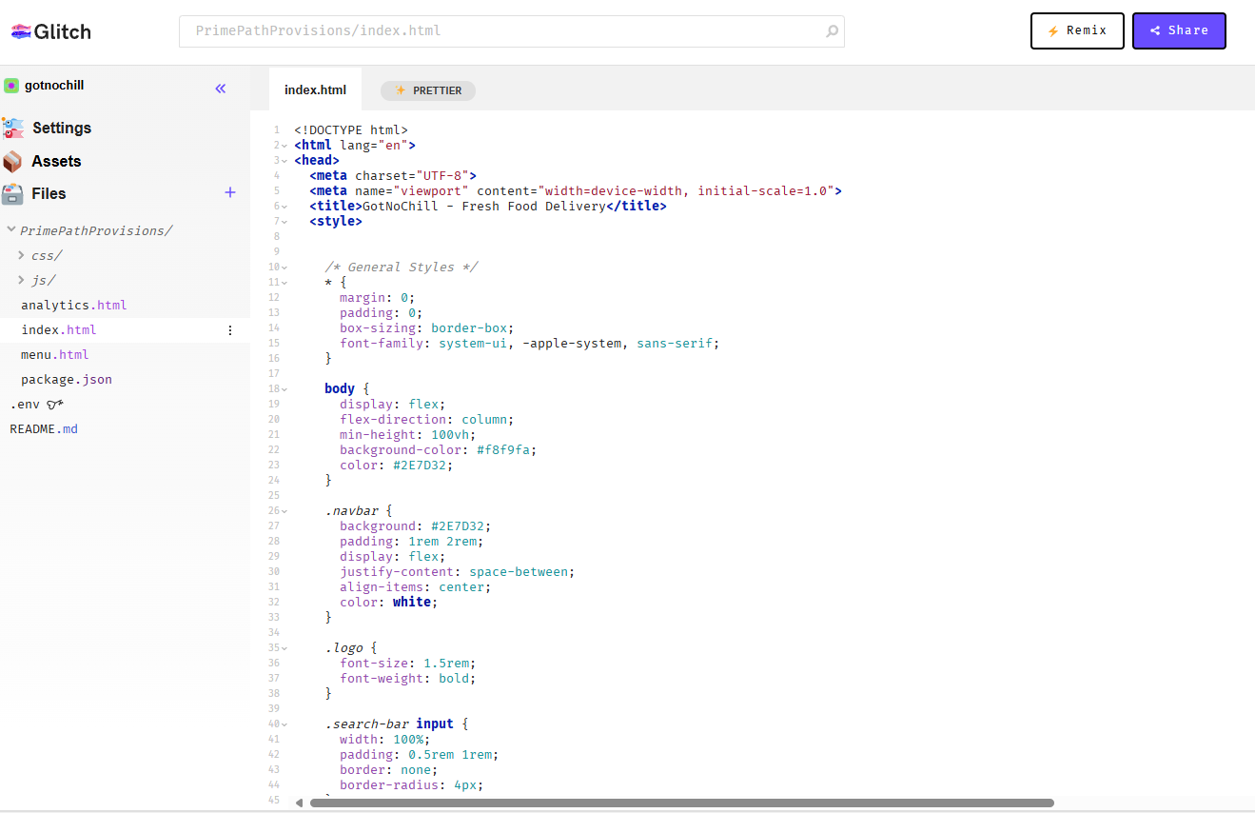

***Figure 35:***

**Pycharm:**

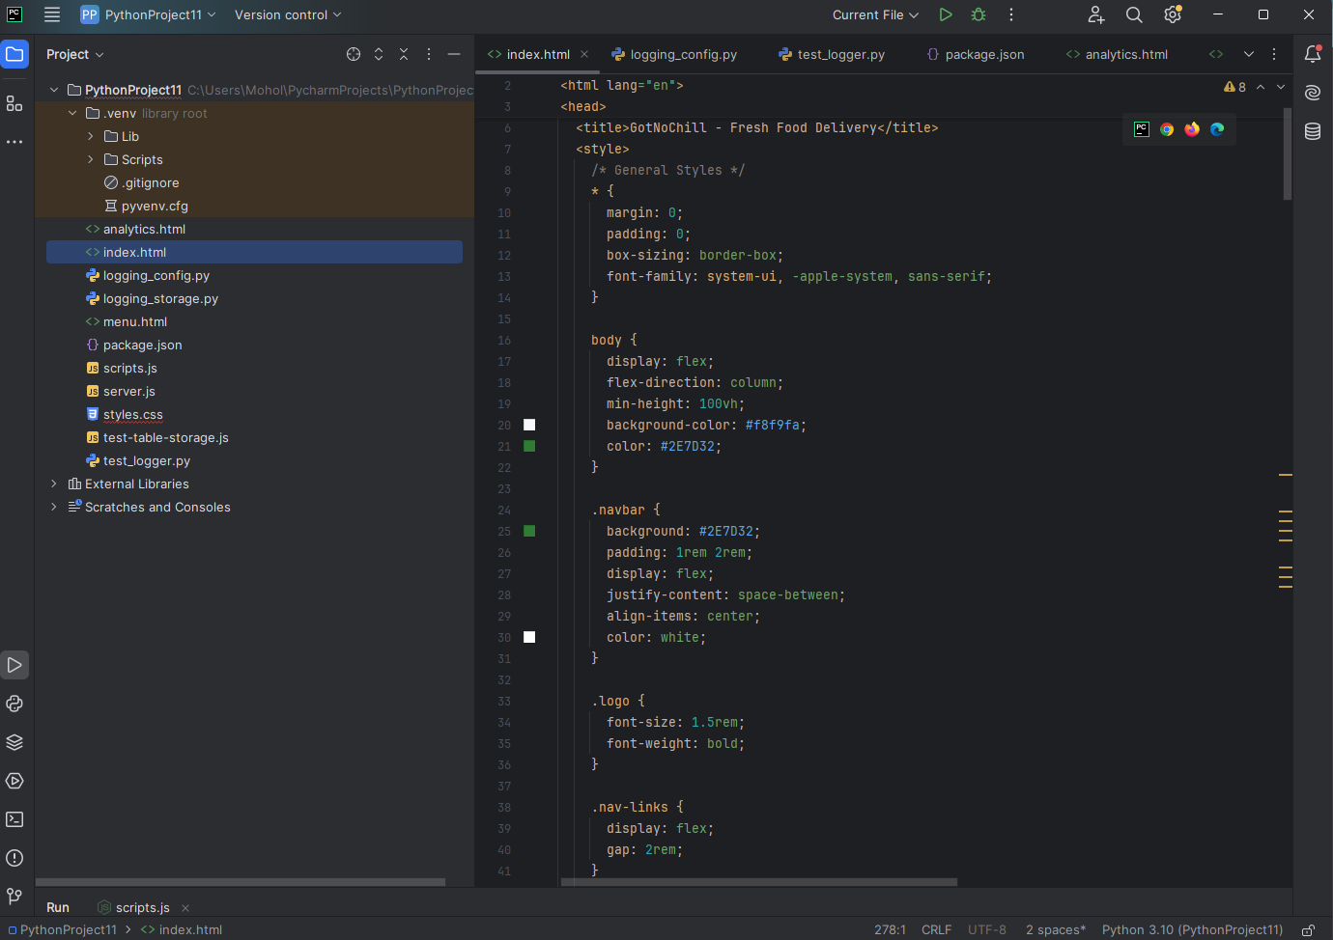

**Unit 6 Screenshots:**

**Azure App Services Deployment:**

***Figure 36:****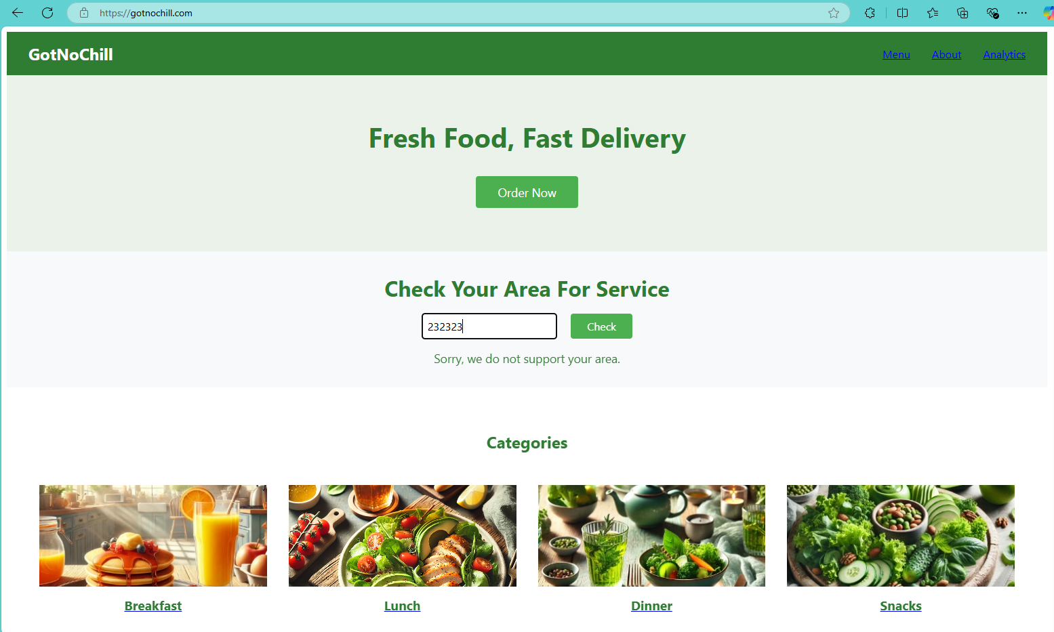*

***Figure 37*:**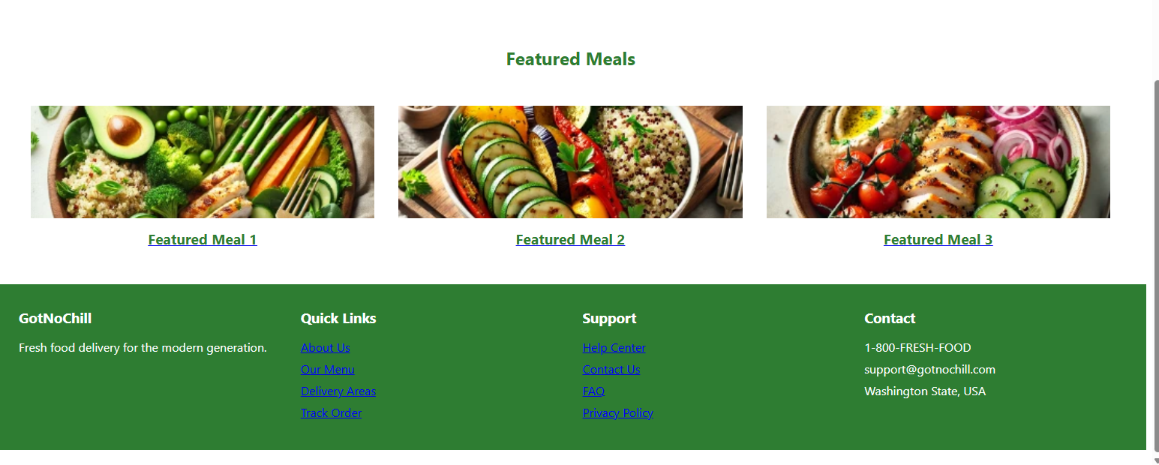

**RBAC Configuration in Azure Active Directory:**

***Figure 38:***

**Description:** Demonstrates the configuration of a custom domain for GotNoChill.com, verifying the secure binding process and alignment with RBAC and NSG policies.

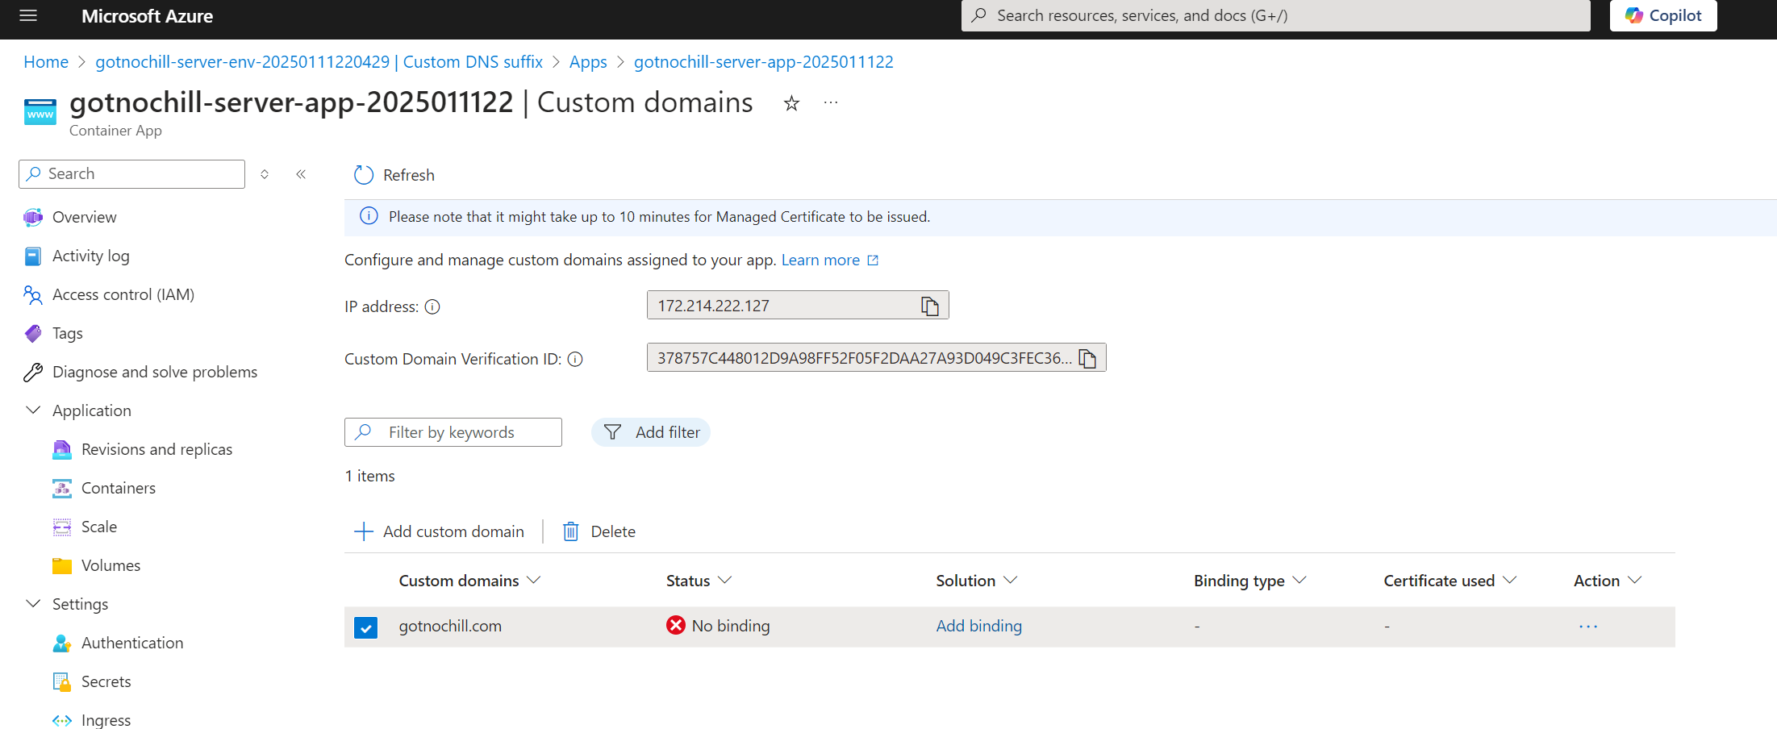

**Azure Monitor Dashboard:**

***Figure 39:***



**Frontend Live Analytics Dashboard:**

***Figure 40*:**

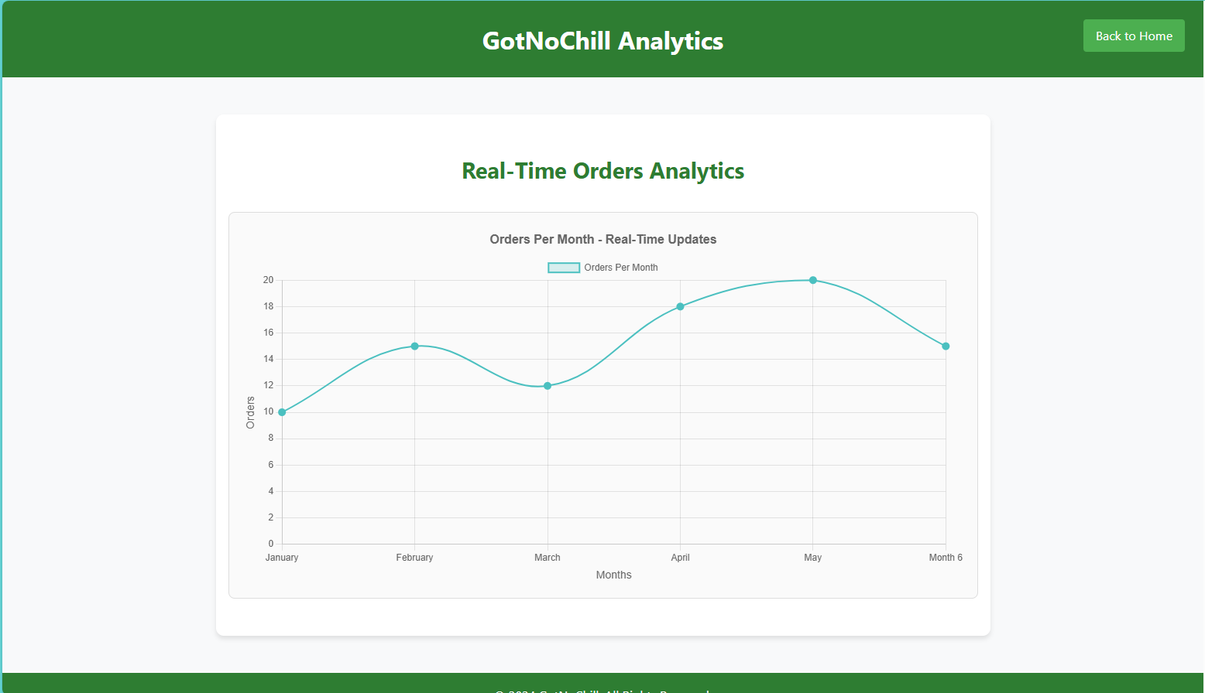

***Figure 41:***

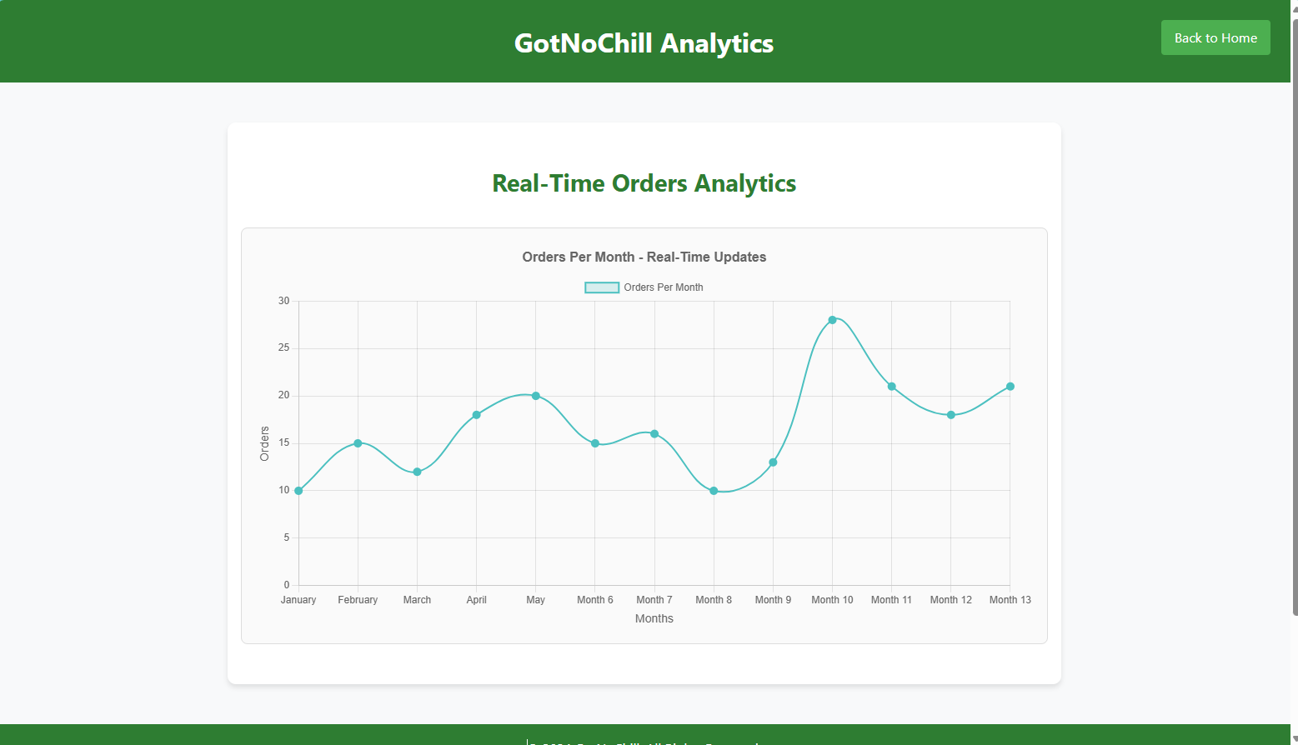

**NSG Rule Updates:**

***Figure 42:***

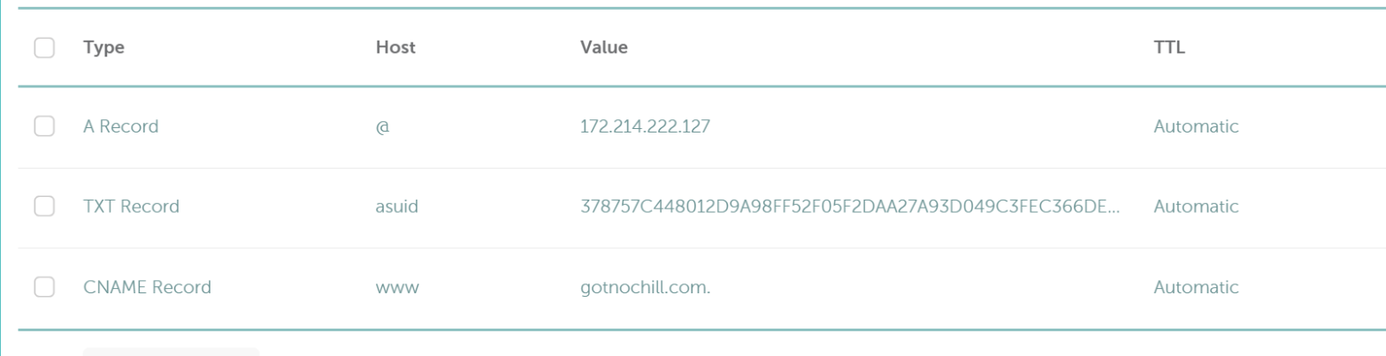

**Backup and Recovery Enhancements:**

***Figure 43:***

**Description:** Highlights the automated creation of the publish profile for streamlined deployment processes. This supports disaster recovery efforts and Azure Monitor integration.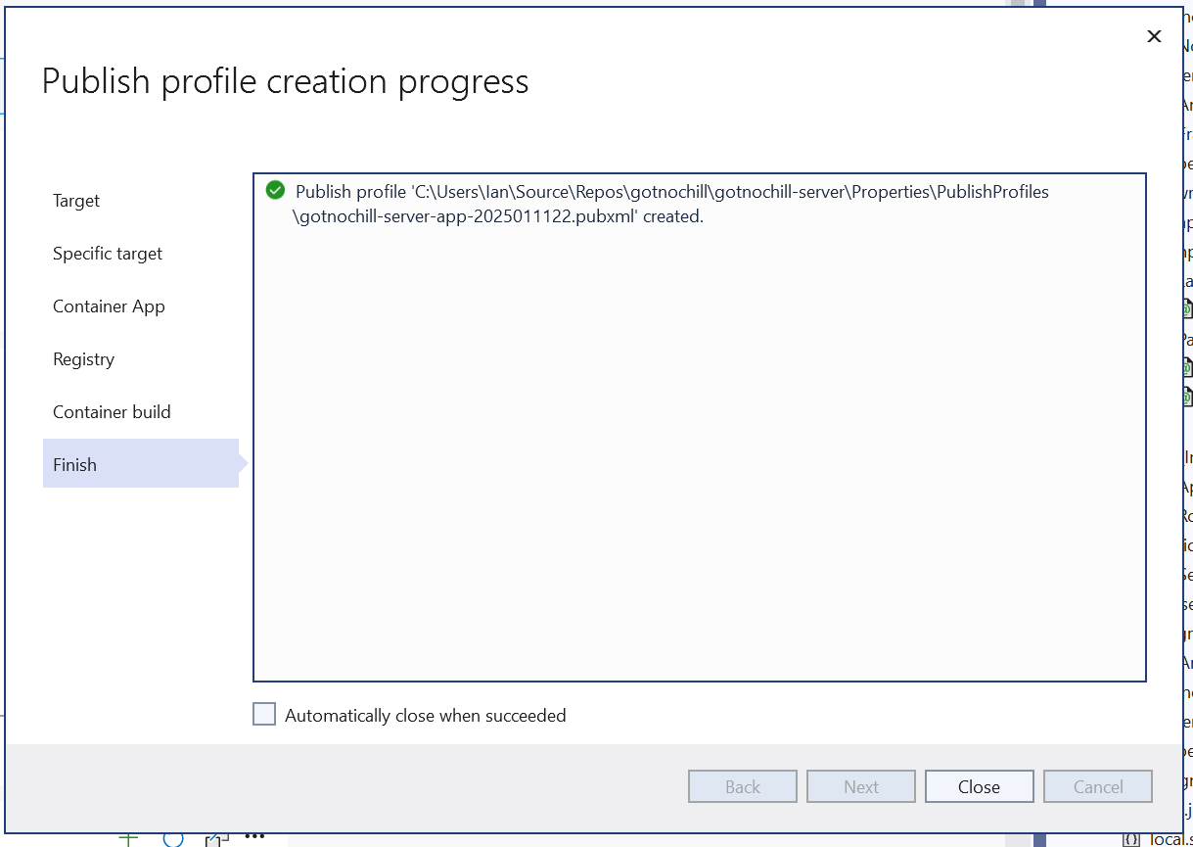

***Figure 44:***

**Description:** Shows the live GotNoChill.com website, reflecting successful NSG rule updates, IP whitelisting, and frontend optimization without compromising accessibility.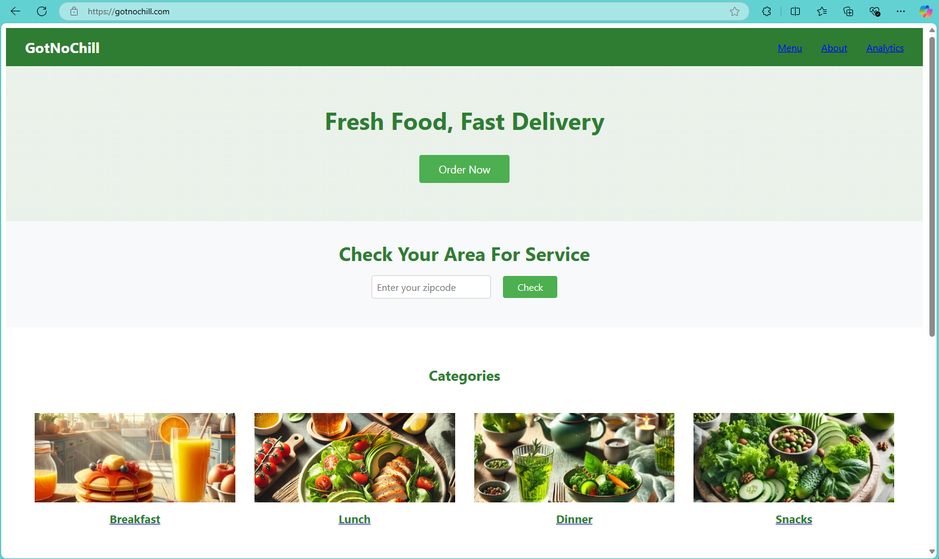

**Unit 7 Scr****eenshots:**

**PostgreSQL Implementation (Local Development)**

*Figure 45:*

**Database Setup in pgAdmin**

* A new database, gotnochill, was created in **pgAdmin** to simulate local development.

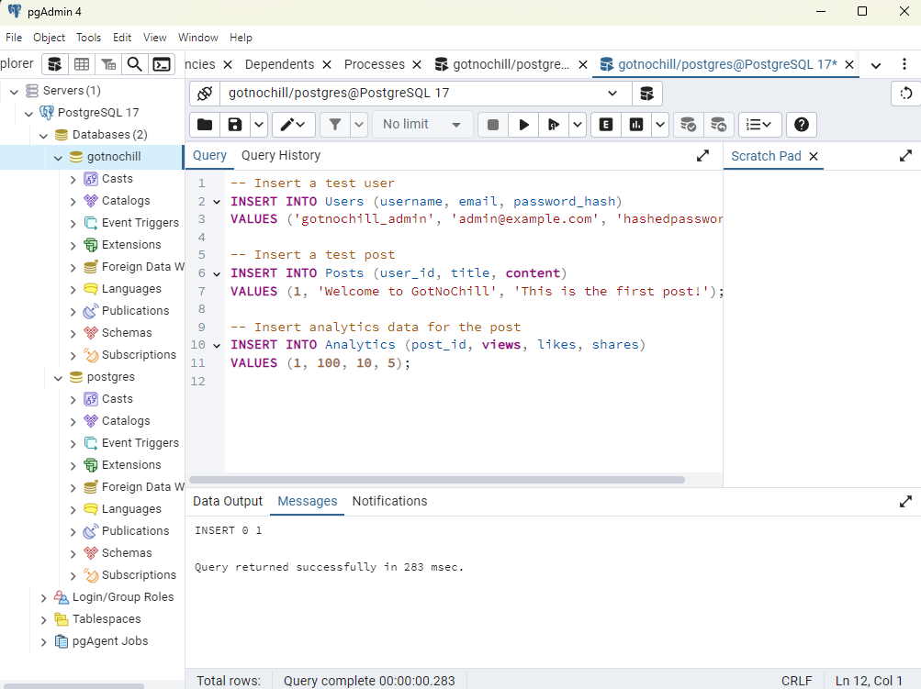

*Figure 46: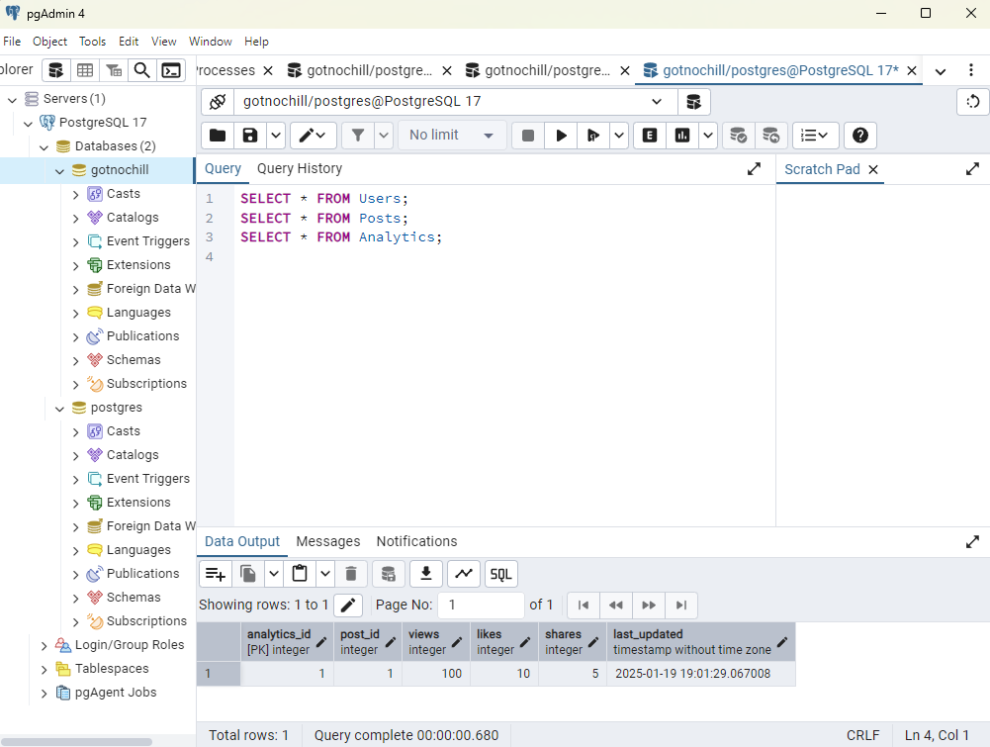*

*Figure 47: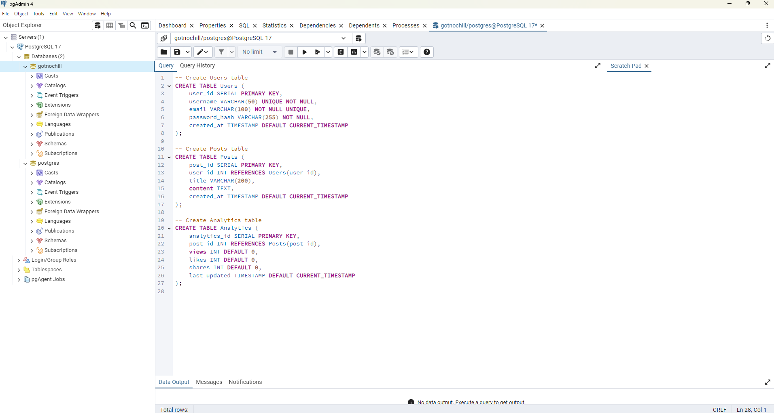*

*Figure 48:*

**Azure SQL Database Implementation**

***Figure 49:***

**Database Deployment on Azure**

* A new **Azure SQL Database** was created and configured:
  + **Database Name:** gotnochill
  + **Server Location:** East US
  + **Pricing Tier:** Basic (suitable for initial testing and development).
  + **Security Configuration:** RBAC through Azure Active Directory.

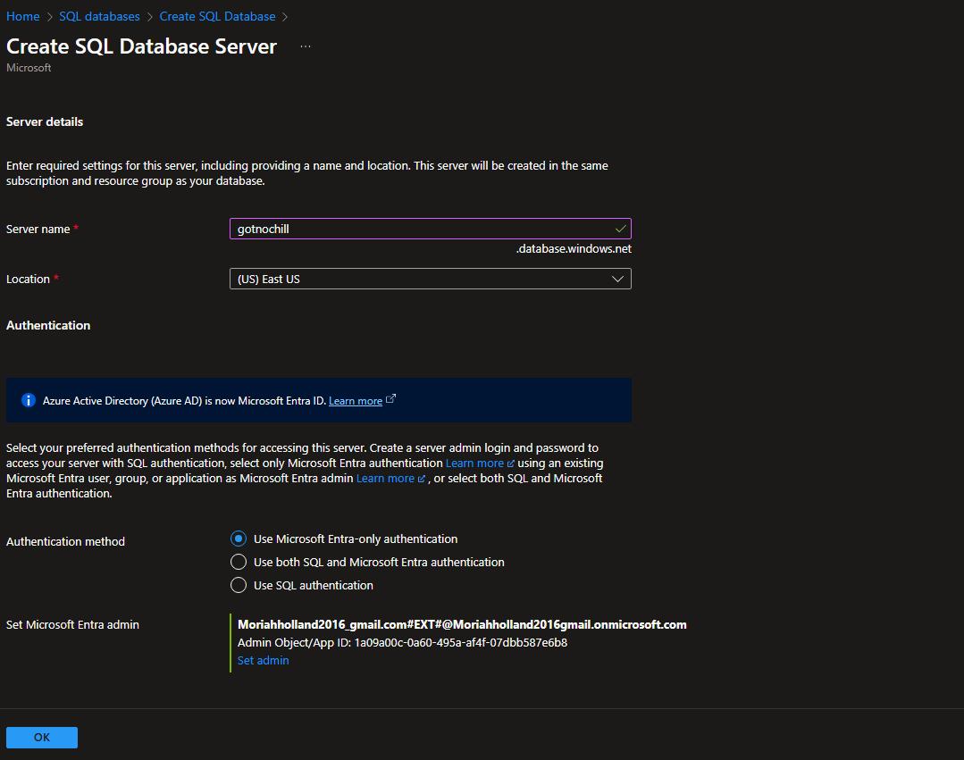

***Figure 50:***

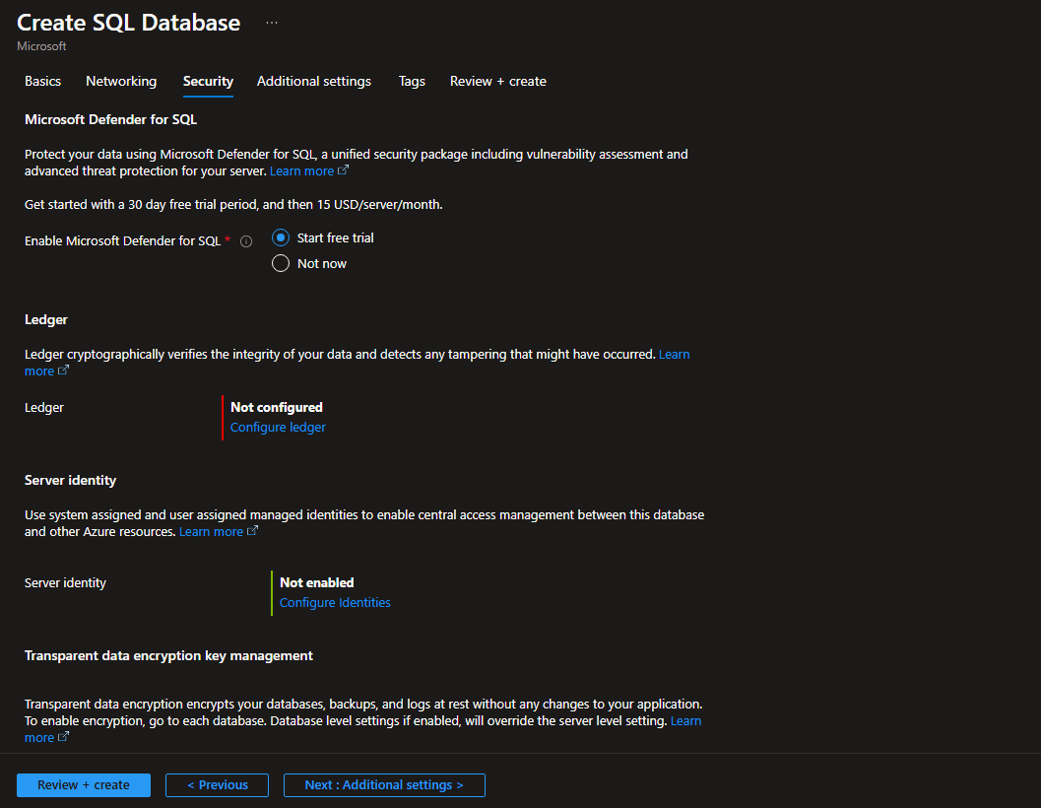

***Figure 51:***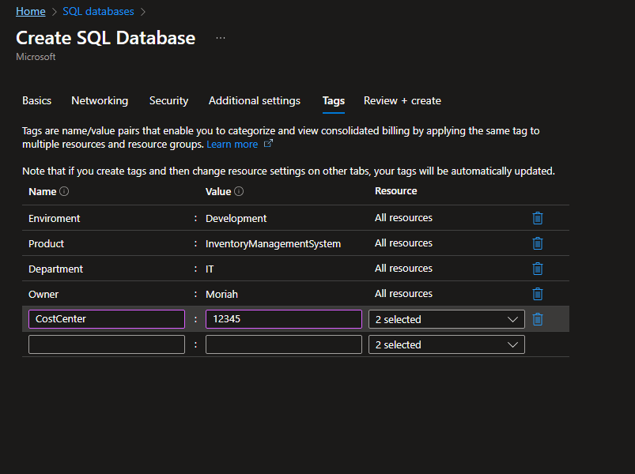

***Figure 52:***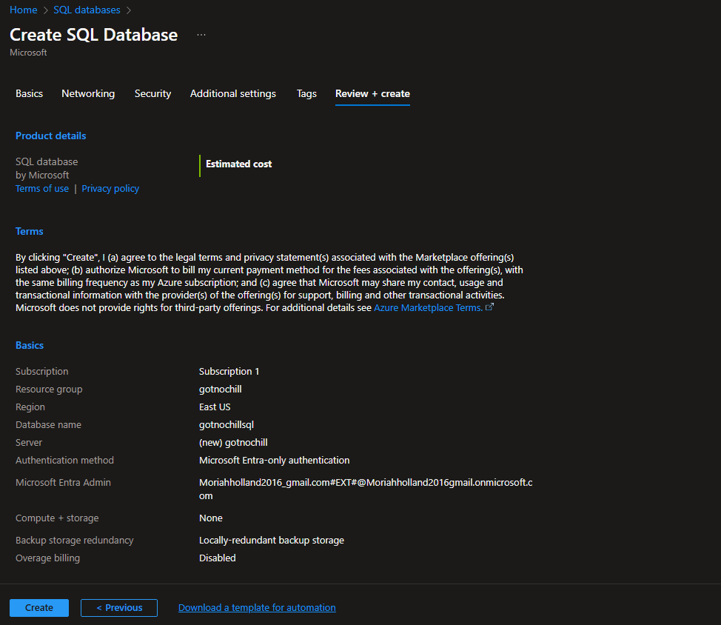

***Figure 53:***

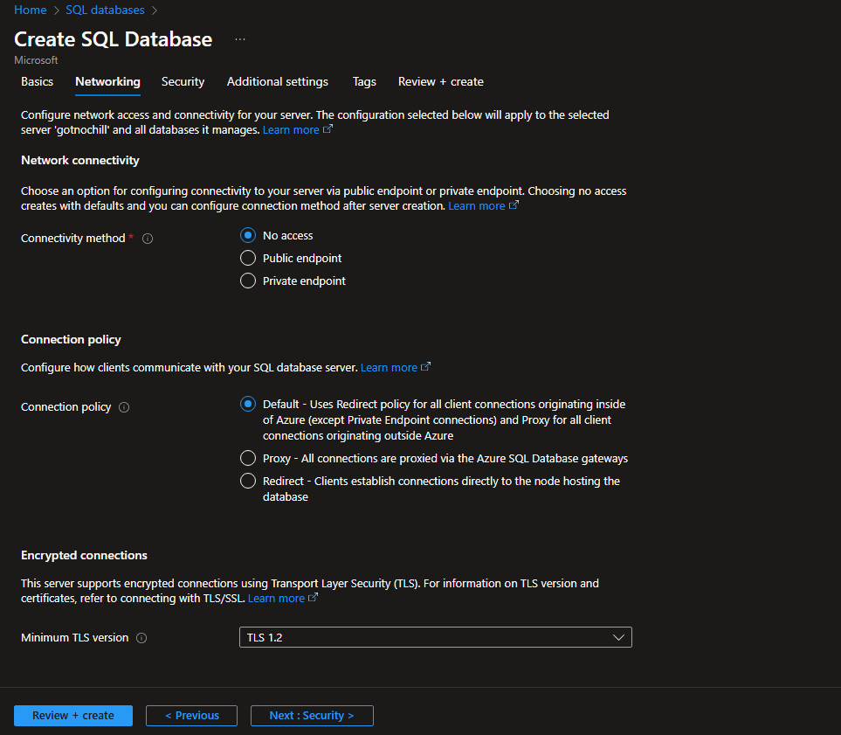

***Figure 54:***

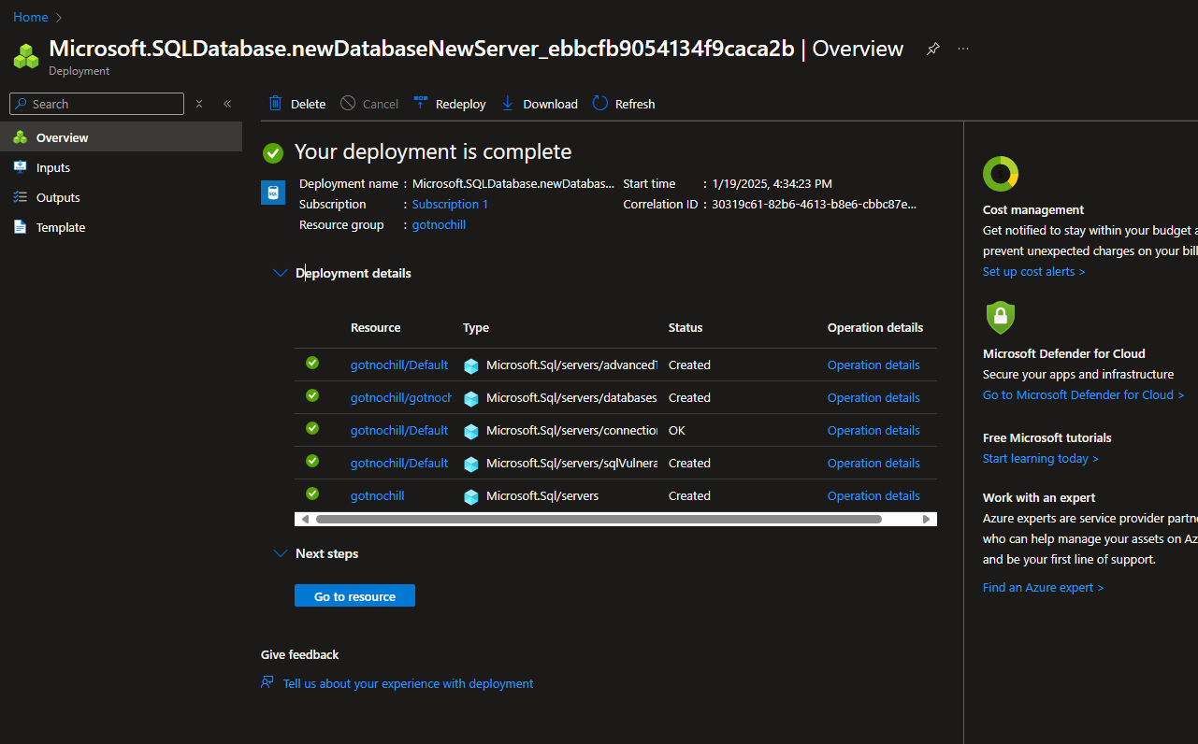

***Figure 55:***

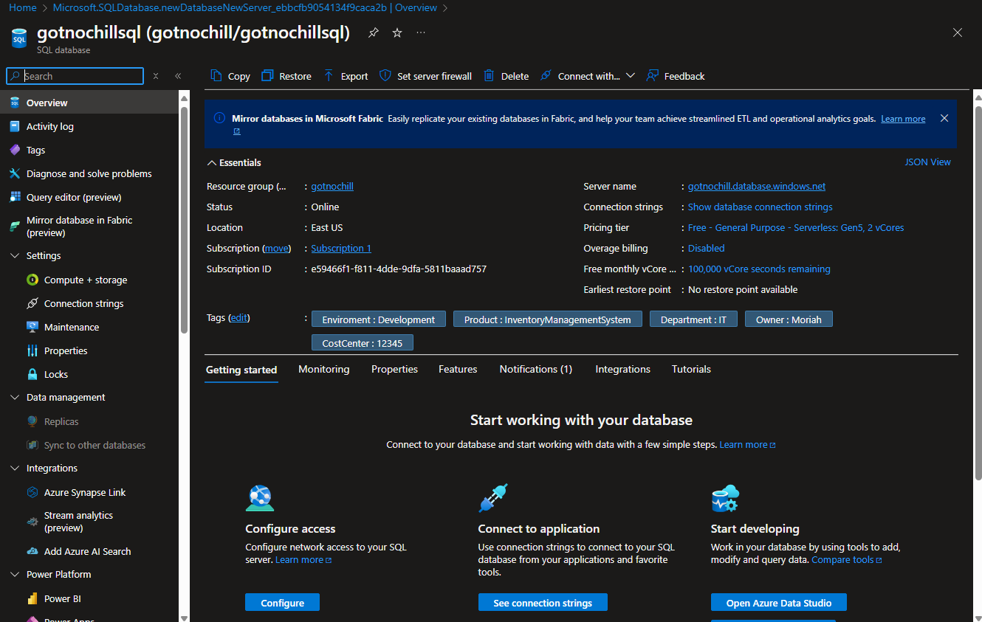

***Figure 56:***

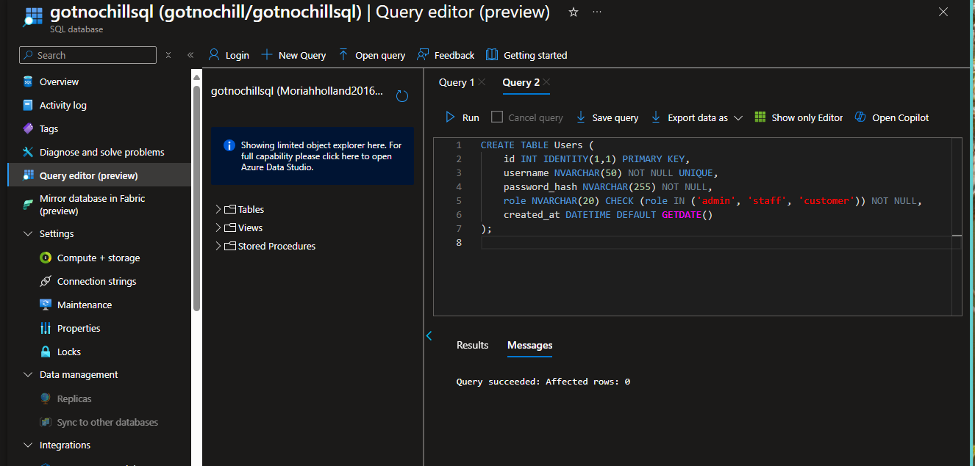

***Figure 57:***

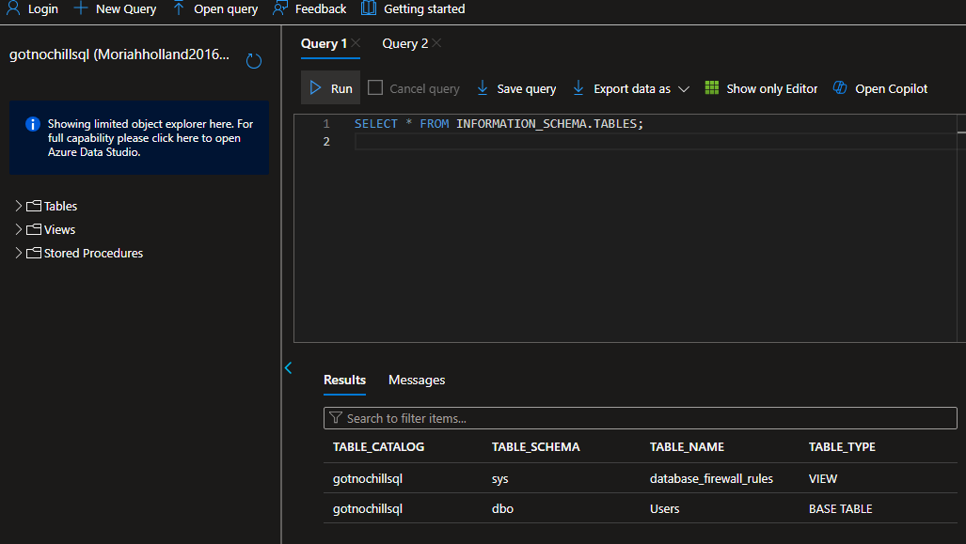

***Figure 58:***

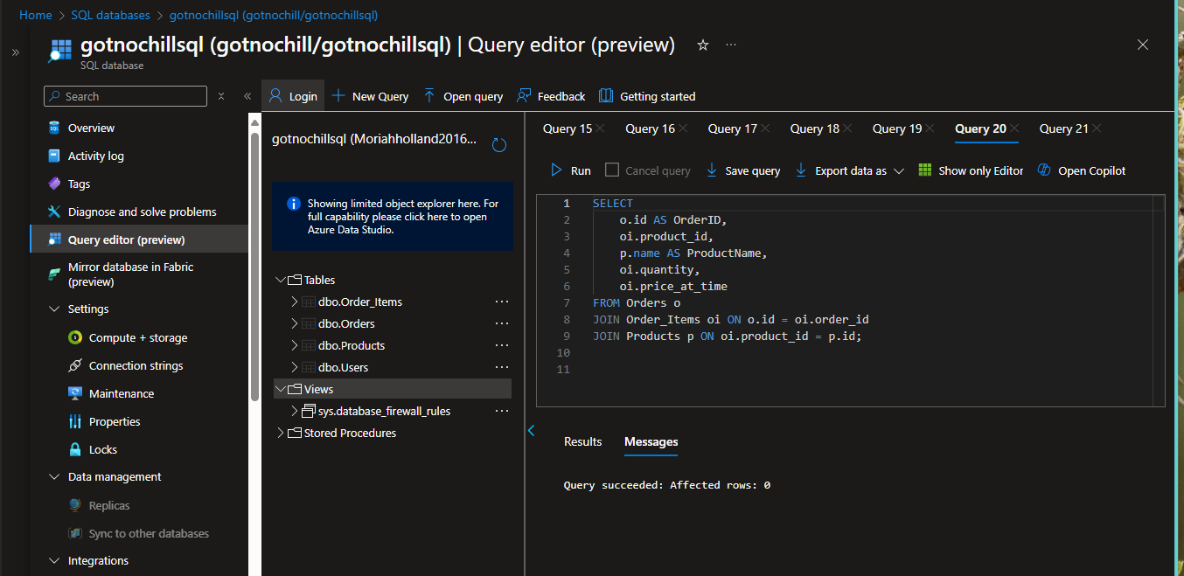

**Set up of Azure Sentinal:**

***Figure 59:***

Log Analytics Workspace Created"

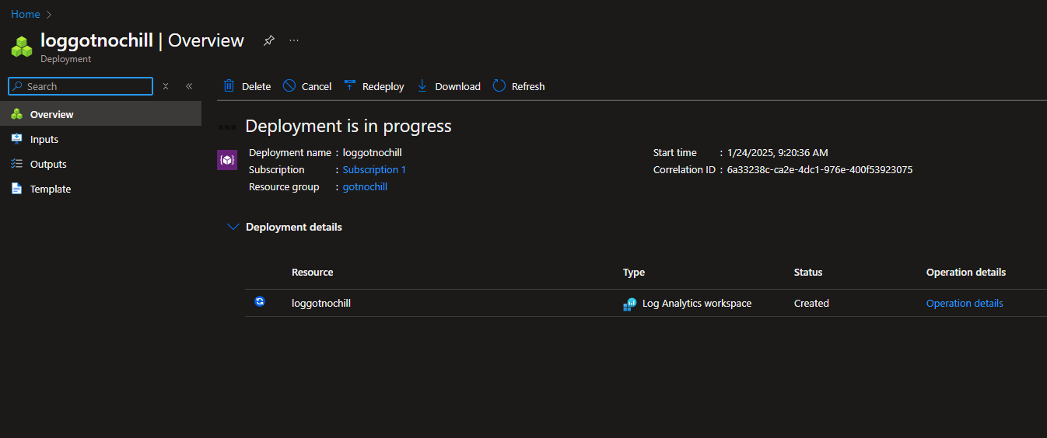

***Figure 60:***

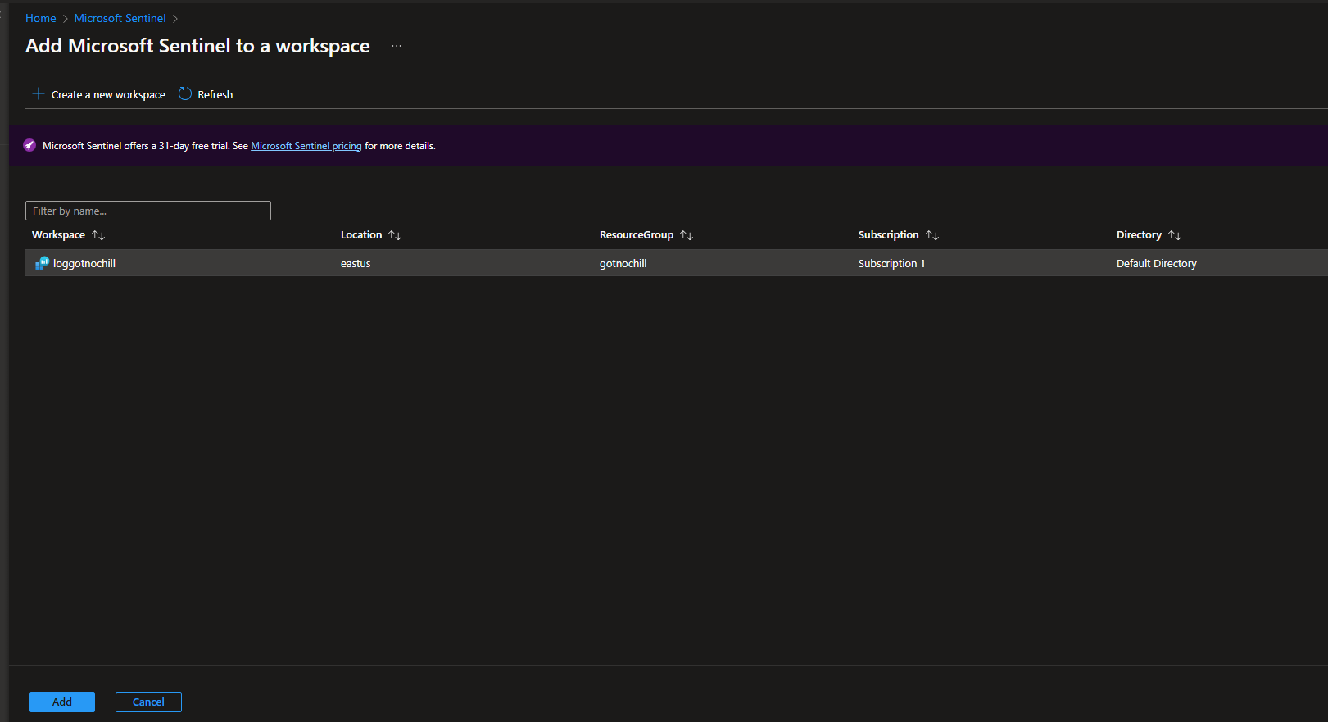

***Figure 61:***

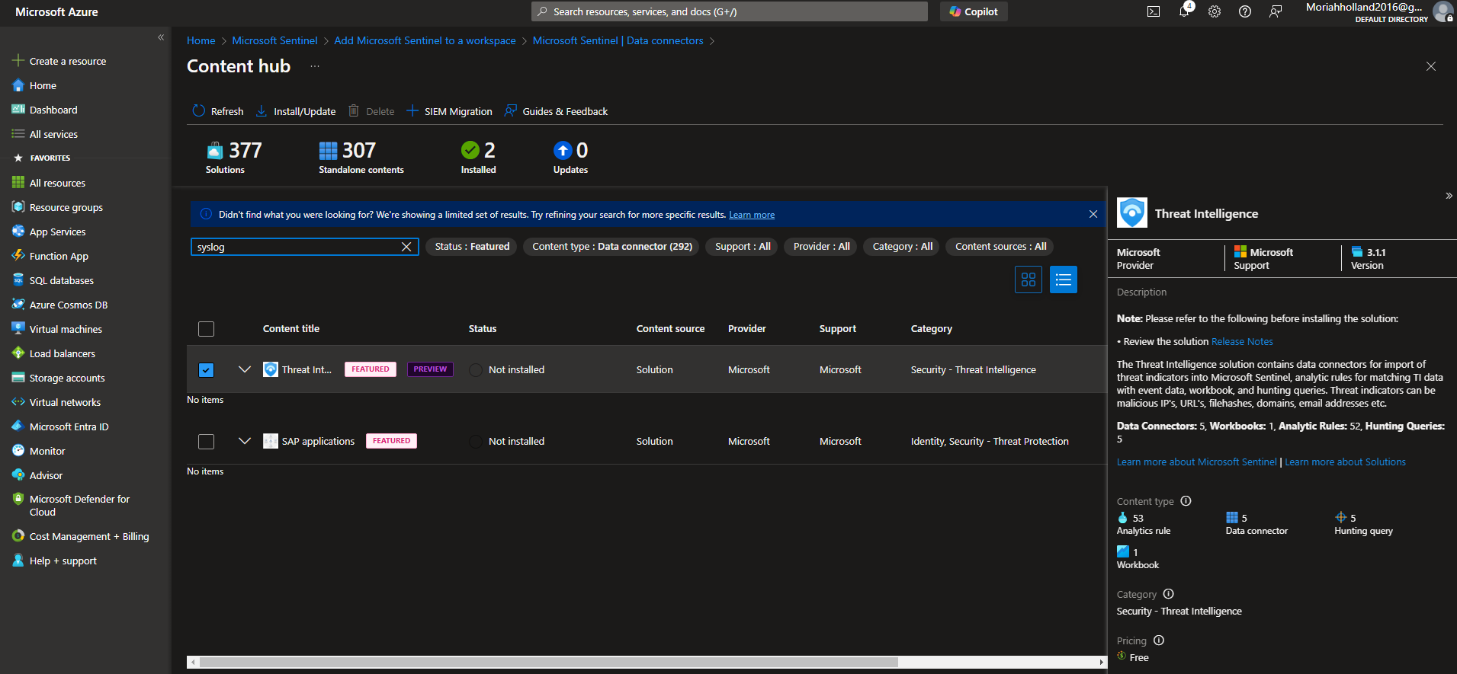

***Figure 62:***

Suspicious Sign-In Rule Configuration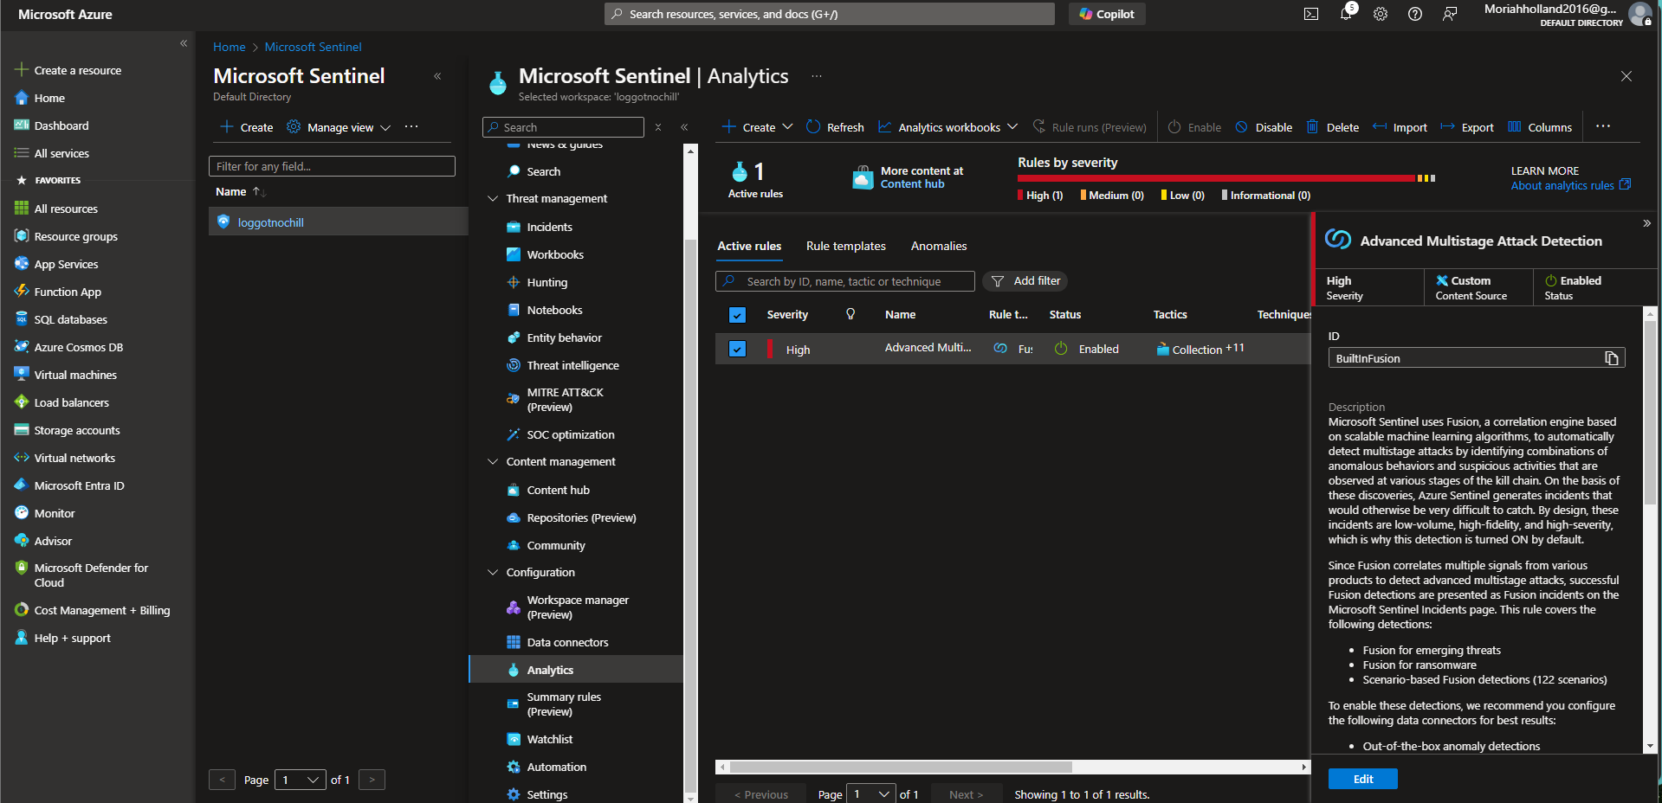

***Figure 63:***

Create rule: 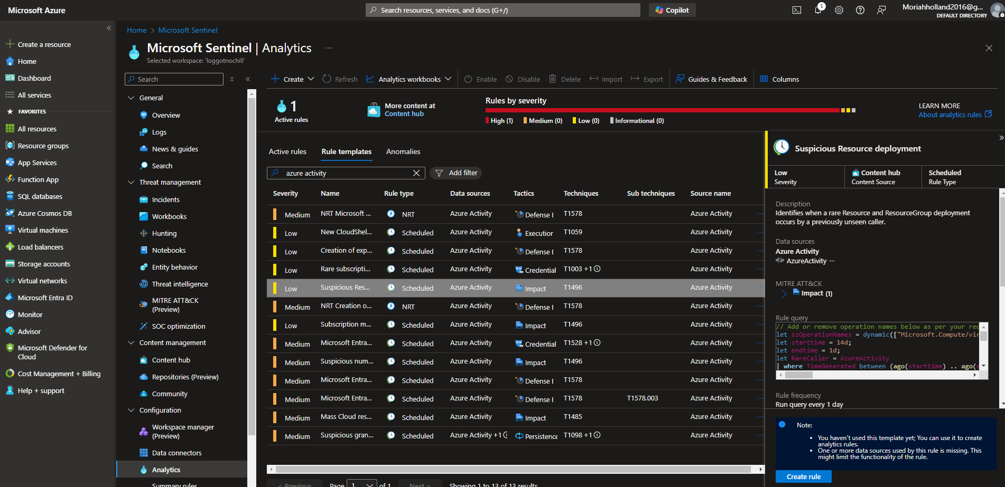

***Figure 64:***

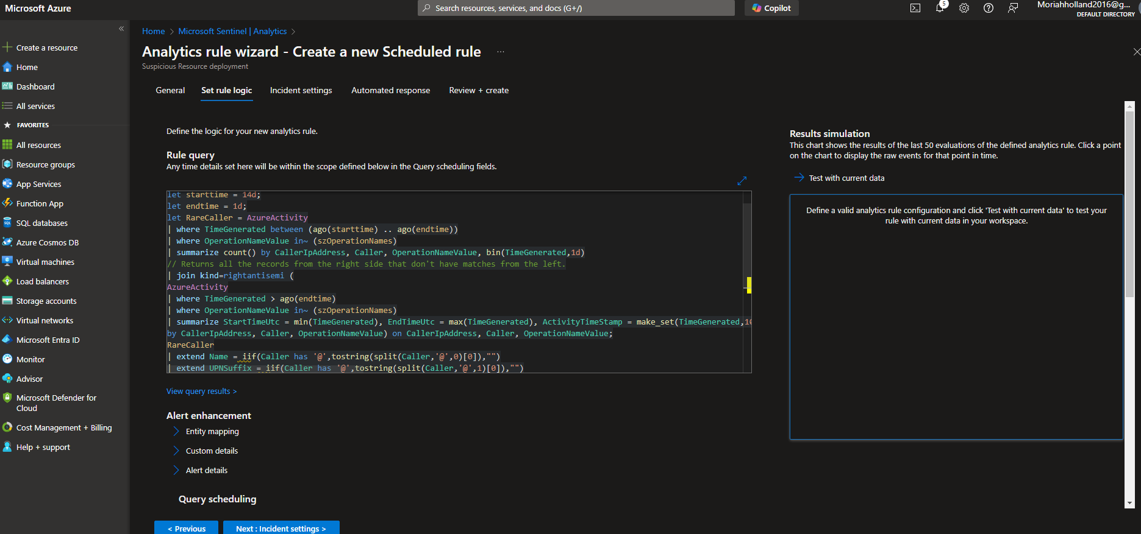

***Figure 66:***

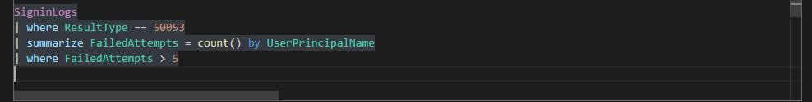

***Figure 67:***

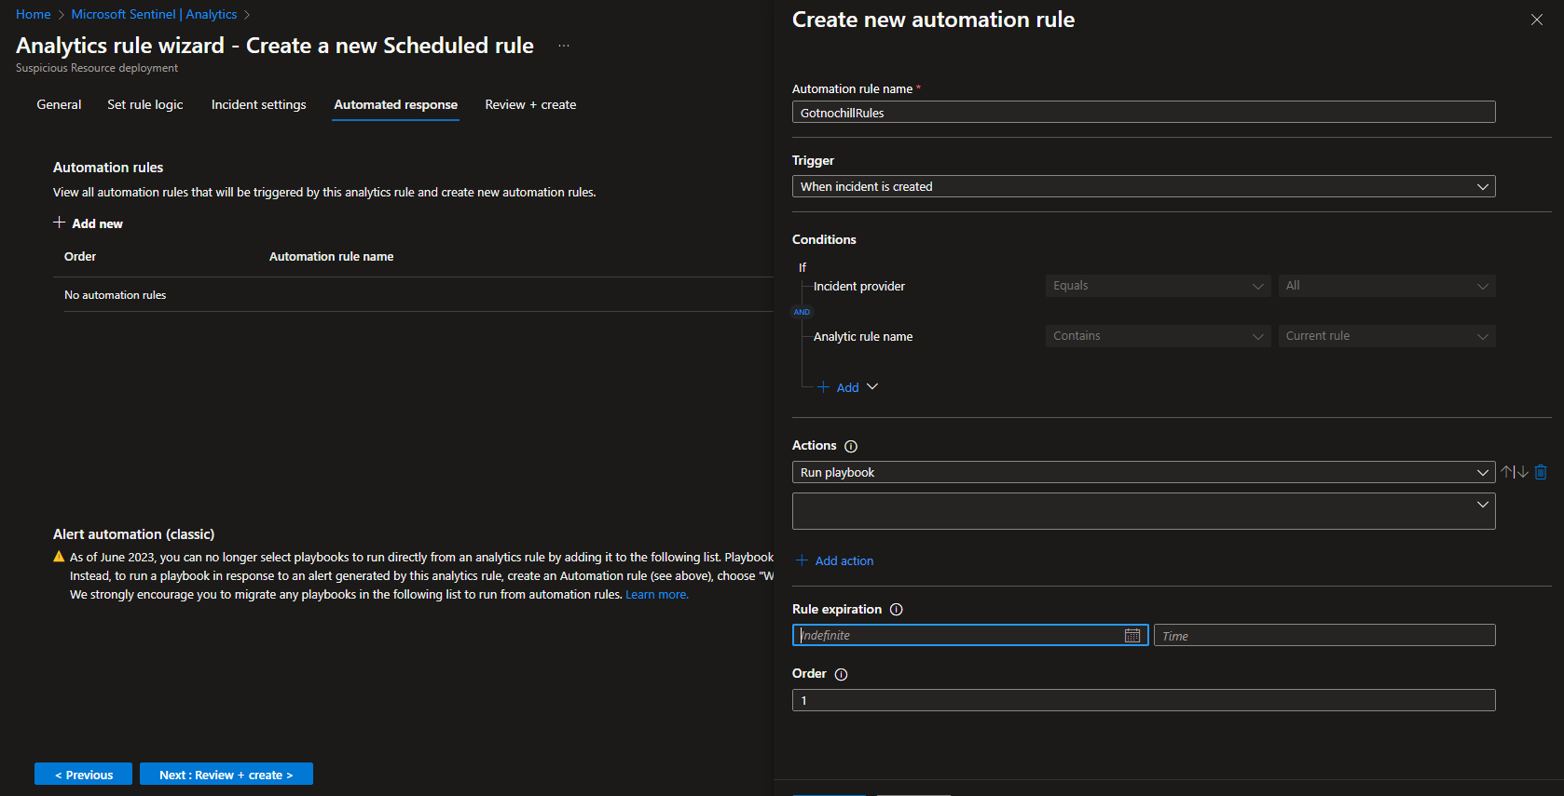

***Figure 68:***

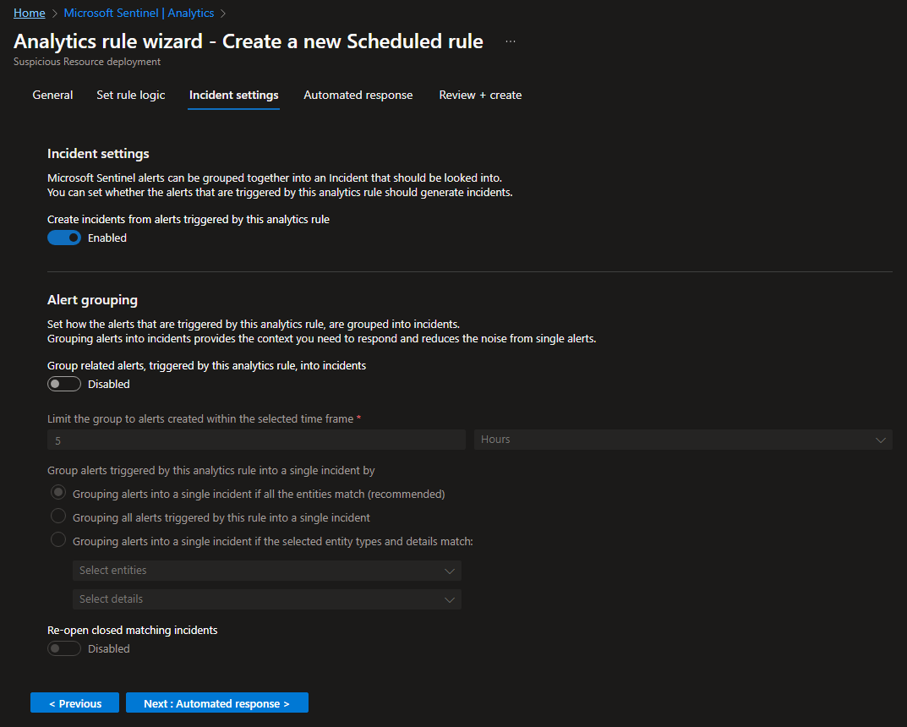

***Figure 69:***

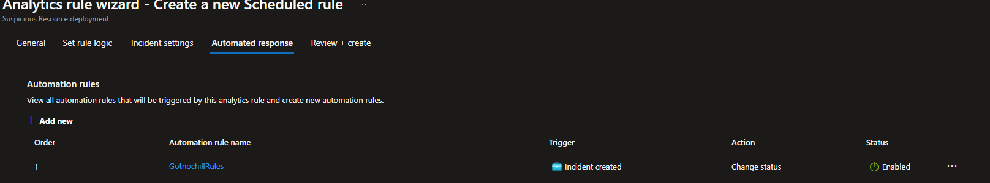

***Figure 70:***

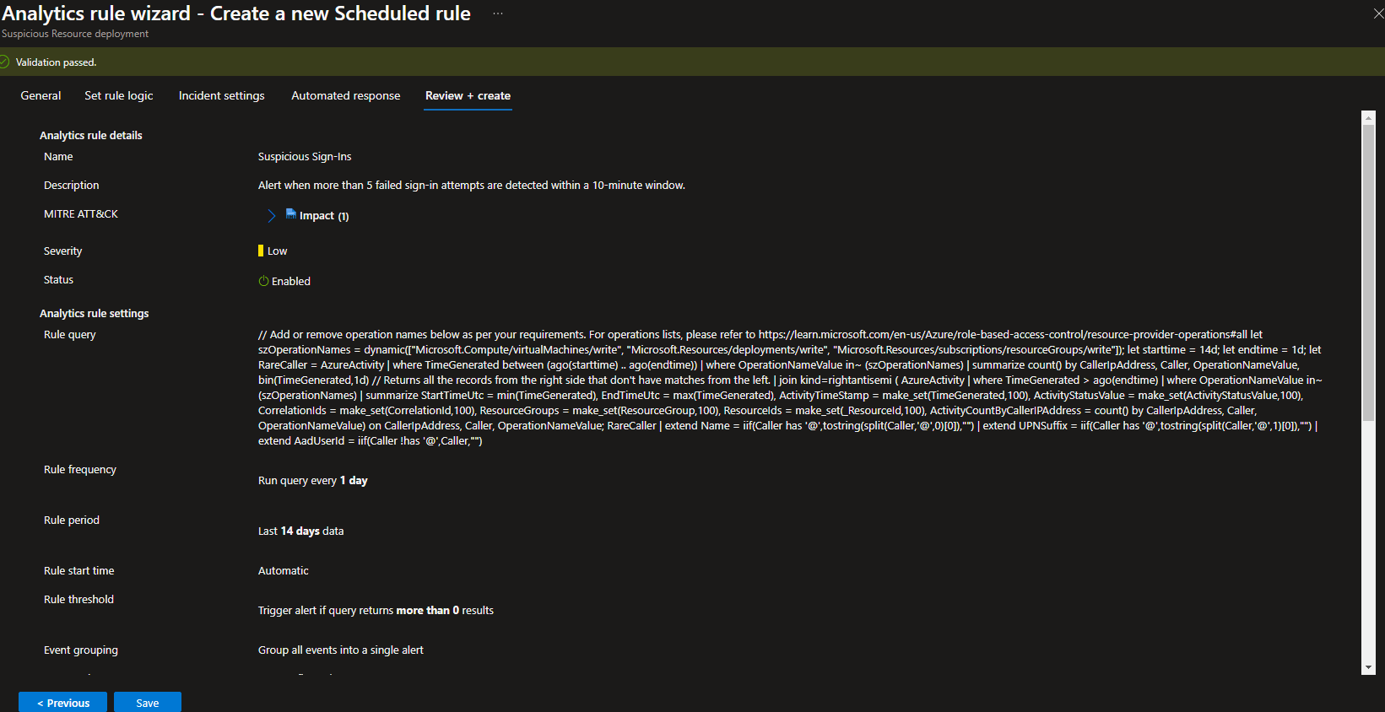

***Figure 71:***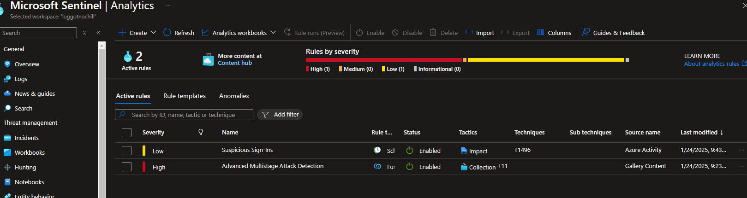

**Testing Framework**

***Figure 72:***

**Unit Testing:**

* + Screenshot of Pytest results or SQL queries tested locally in pgAdmin.

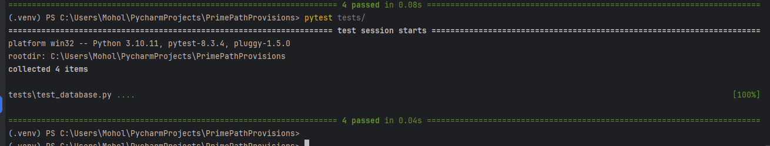

***Figure 73:***

**End-to-End Testing:**

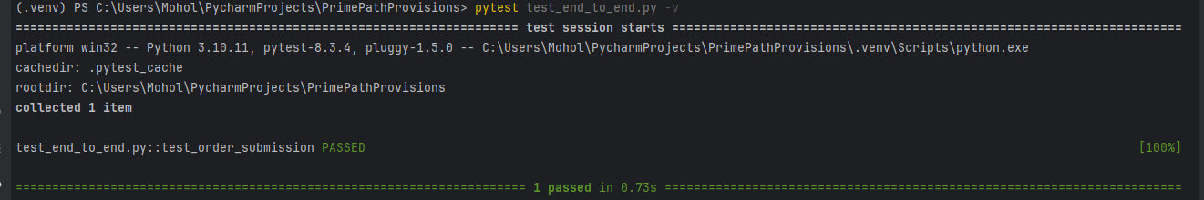

***Figure 74:***

**Business Acceptance Testing:**

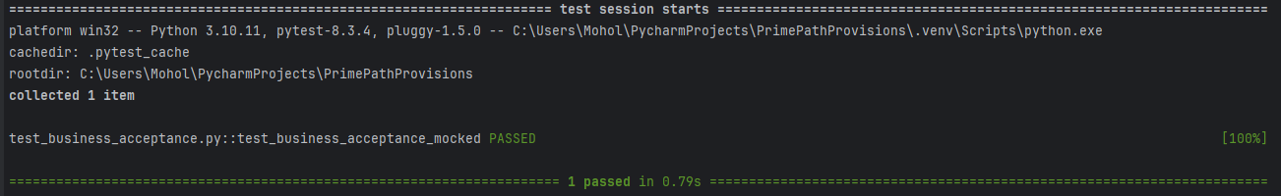

***Figure 75:***

Screenshot of GotNoChill ordering page confirming successful order placement during End-to-End Functional Testing.

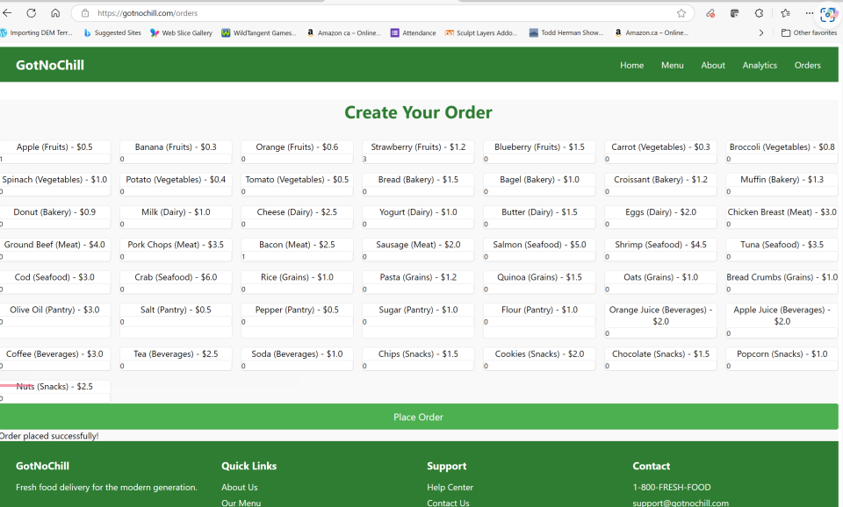

**12-Factor App Implementation**

1. **Configuration and Dependencies:**

***Figures 76:***

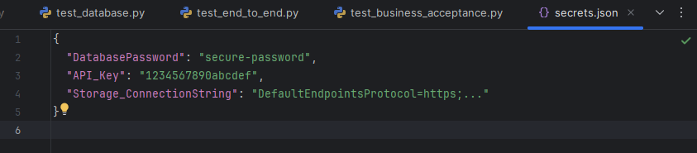

***Figure 77:***

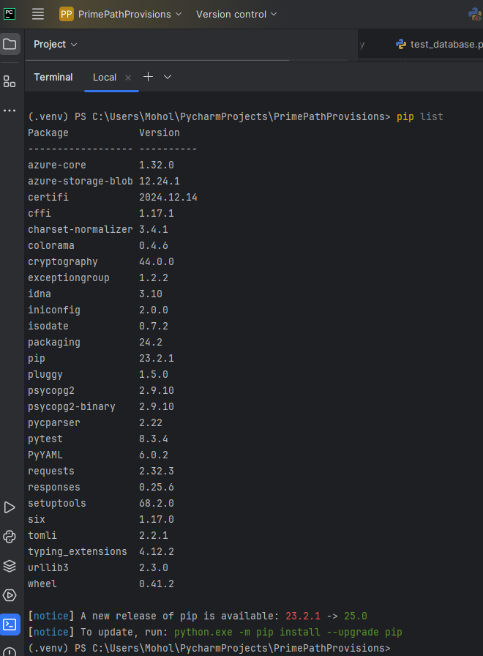

**Port Binding:**

***Figure 78:***

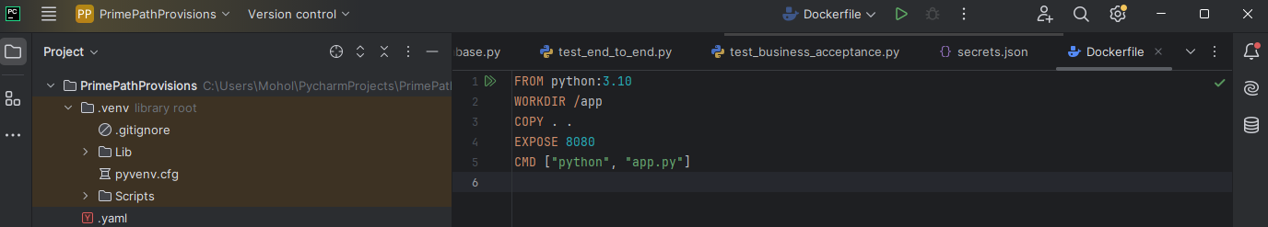

***Figure 79:***

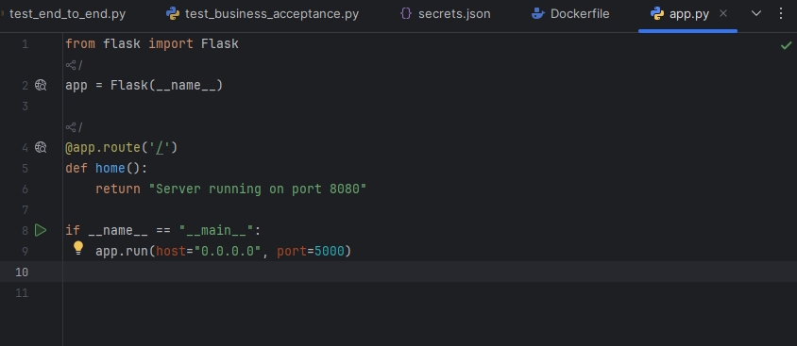

***Figure 80:***

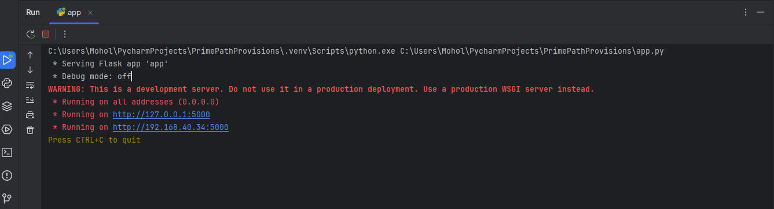

**Scaling:**

***Figure 81:***

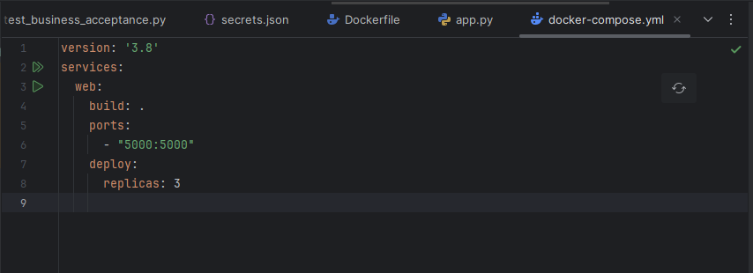

***Figure 82:***

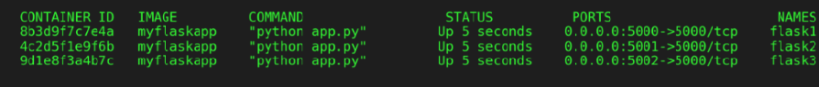

**AI & Cloud Computing Ethics**

Figure:

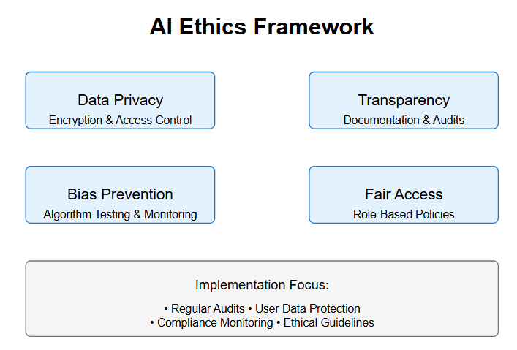

Figure:

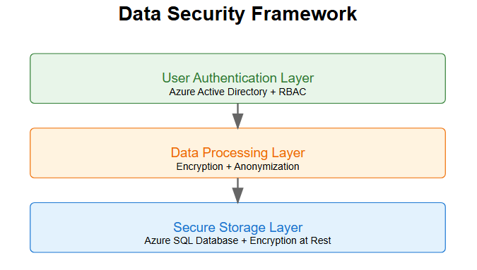

**Part 3:**